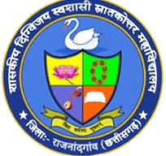
GOVT. DIGVIJAY AUTONOMOUS PG COLLEGE, RAJNANDGAON, CG

AFFILIATED TO
Hemchand Yadav Vishwavidyalaya, Durg
Reaccredited B++ by NAAC

NCC ACTIVITY
2023-24

National women's day
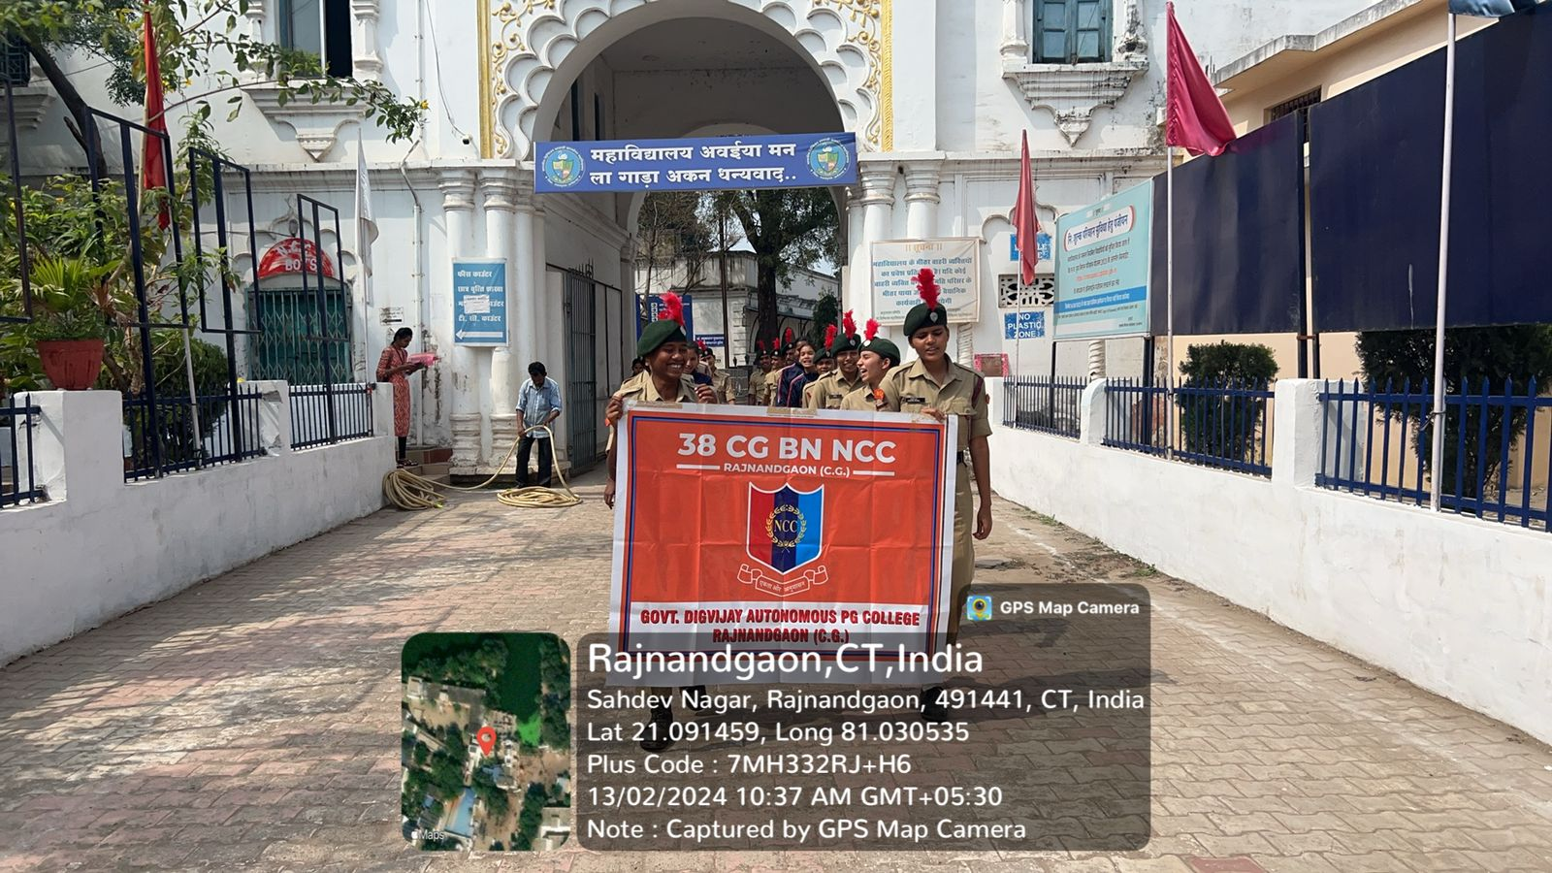

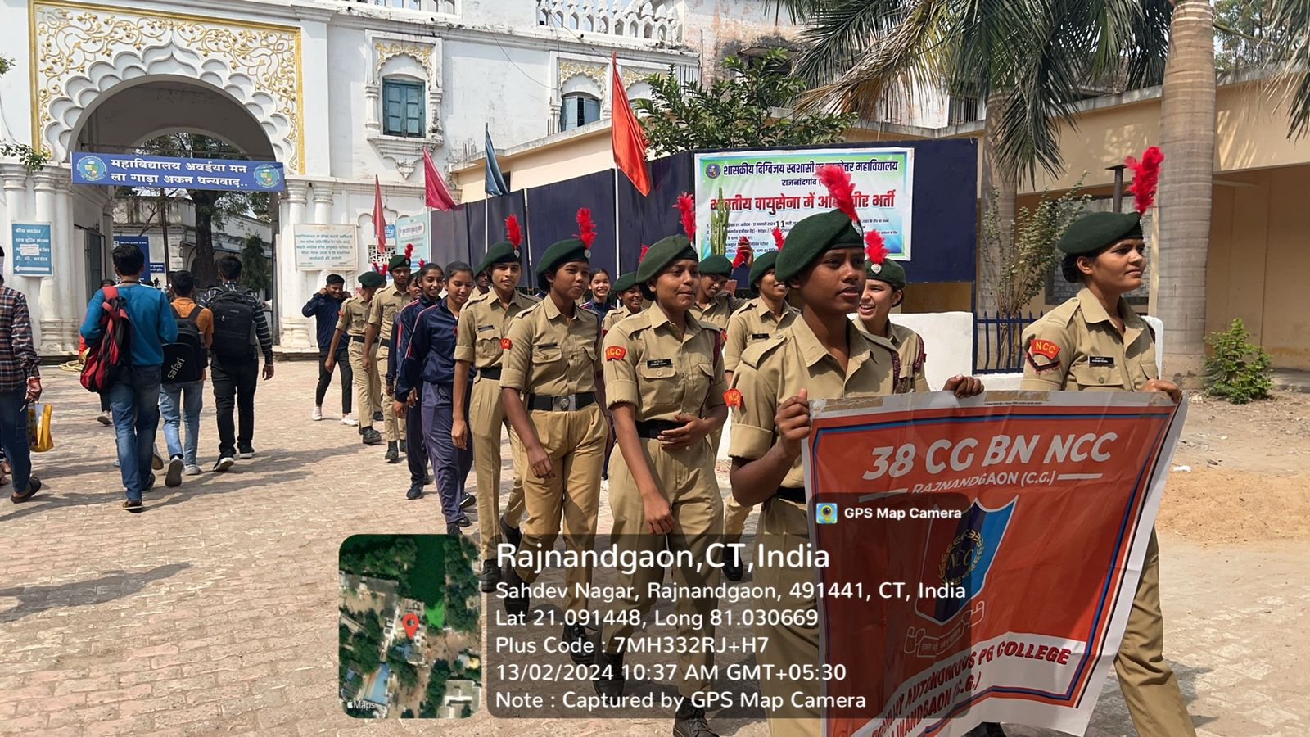

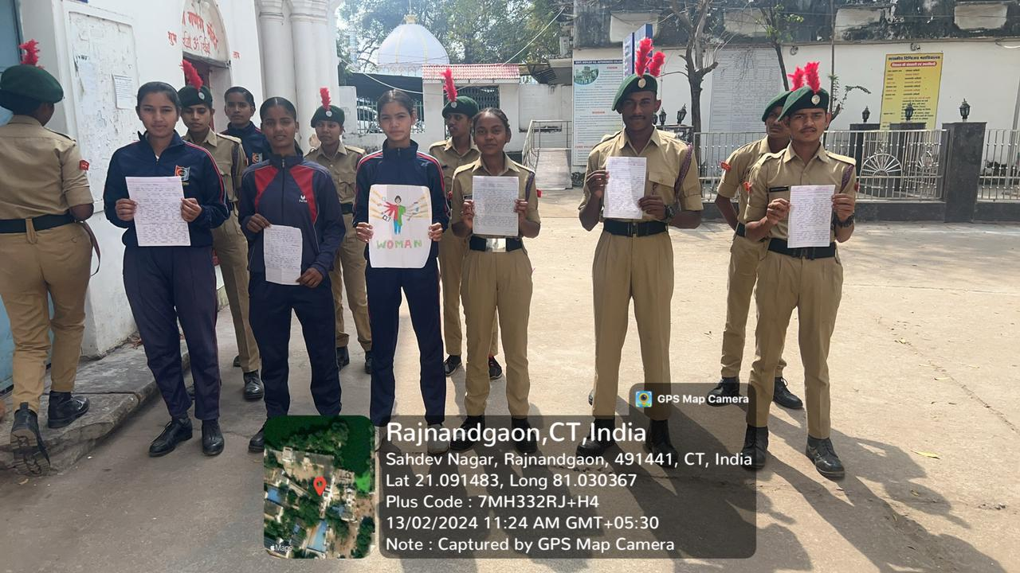

Ser No | Name of institution | No of Cadet | Date of Event | Remarks
1 | Govt.Digvjay Autonomous College | 52 | 13-02-2024 | Poster writing, Railly,Easy writing

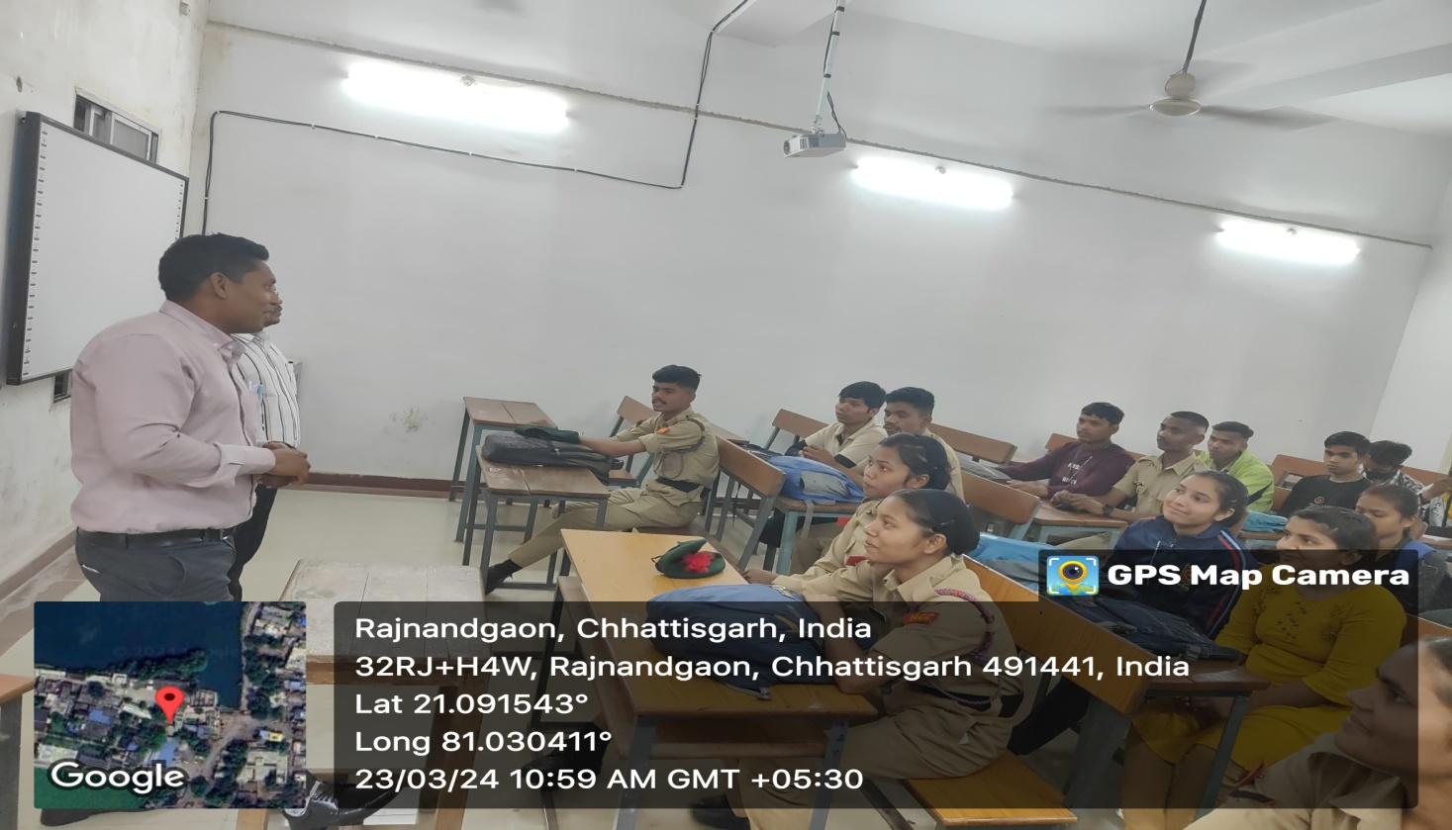
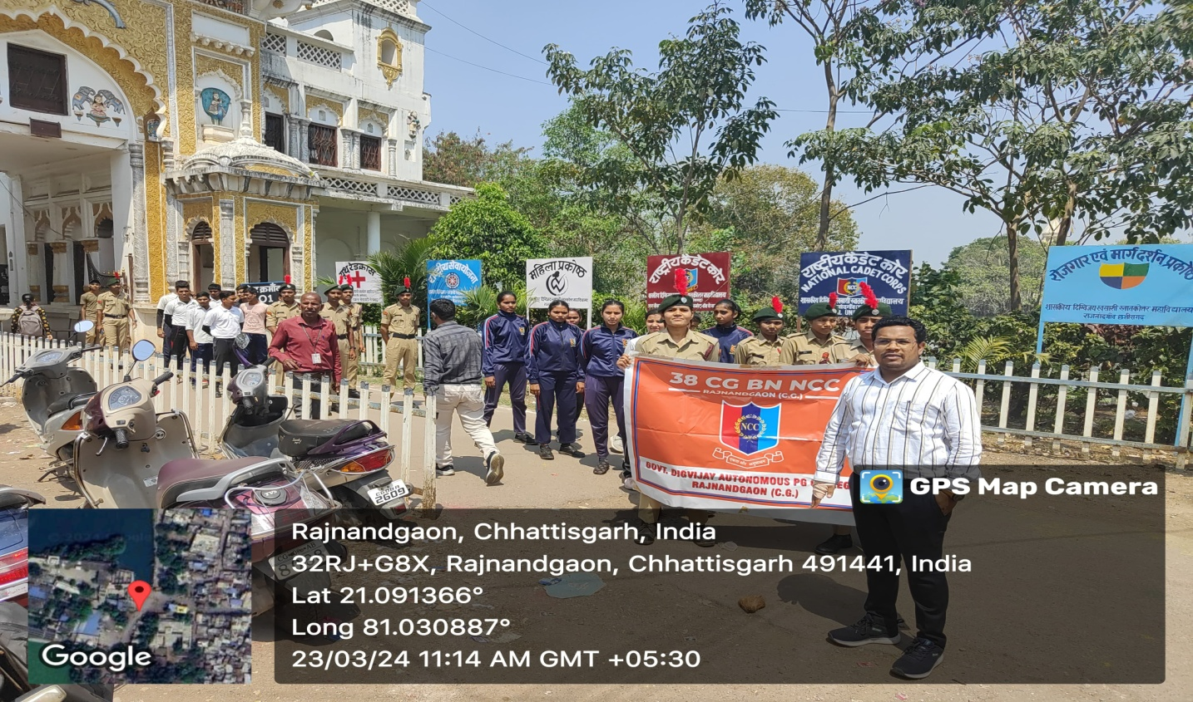
Earth hour programme

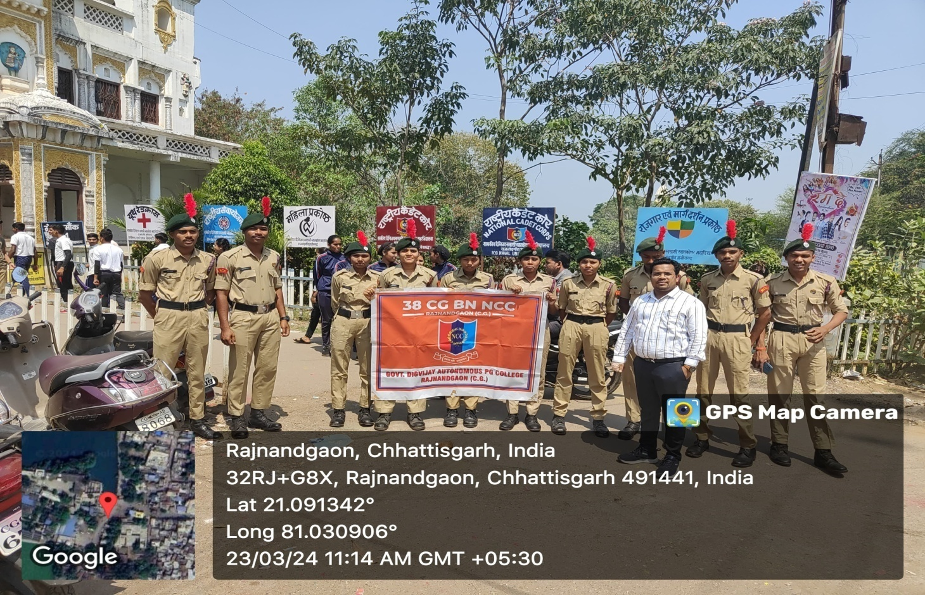

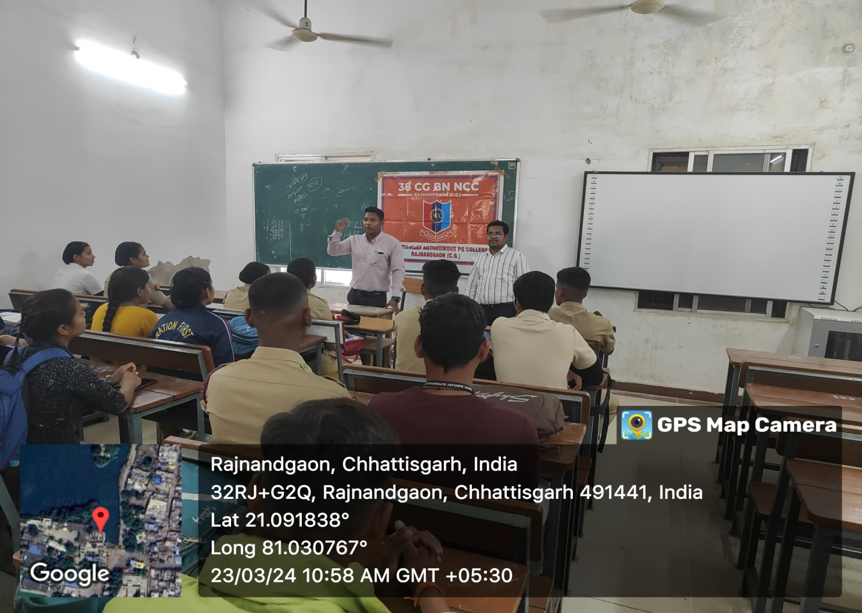

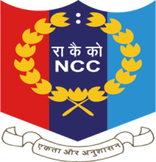
38 CHHATTISGARH BATTALION NCC
GOVT. DIGVIJAY AUTO. PG COLLEGE RAJNANDGAON (C.G.)

NCC Date 23/03/2024

EARTH HOUR AWARENESS PROGRAMME 2024

Ser No | Date  (DDMMYY) | Name of Activities | No of Cadets Participants | Location | Remarks
1 | 23/03/24 | - Lecture on Earth Hour.  - Awareness Railly on earth hour. | 47 | Govt. Digvijay college and shitla mandir area.

SICKLE CELL AND THALASSEMIA DAY
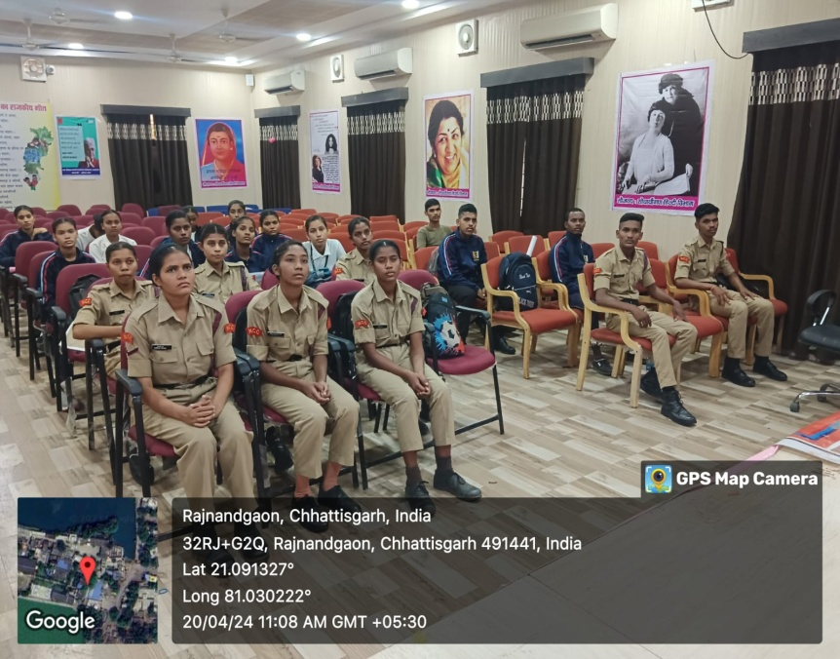
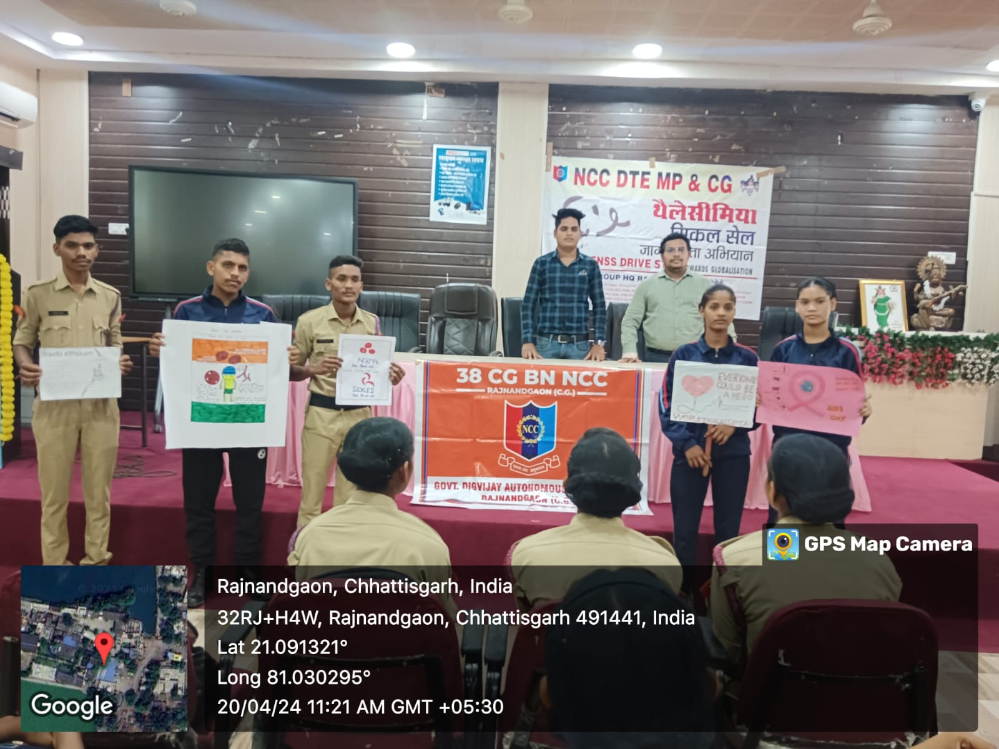

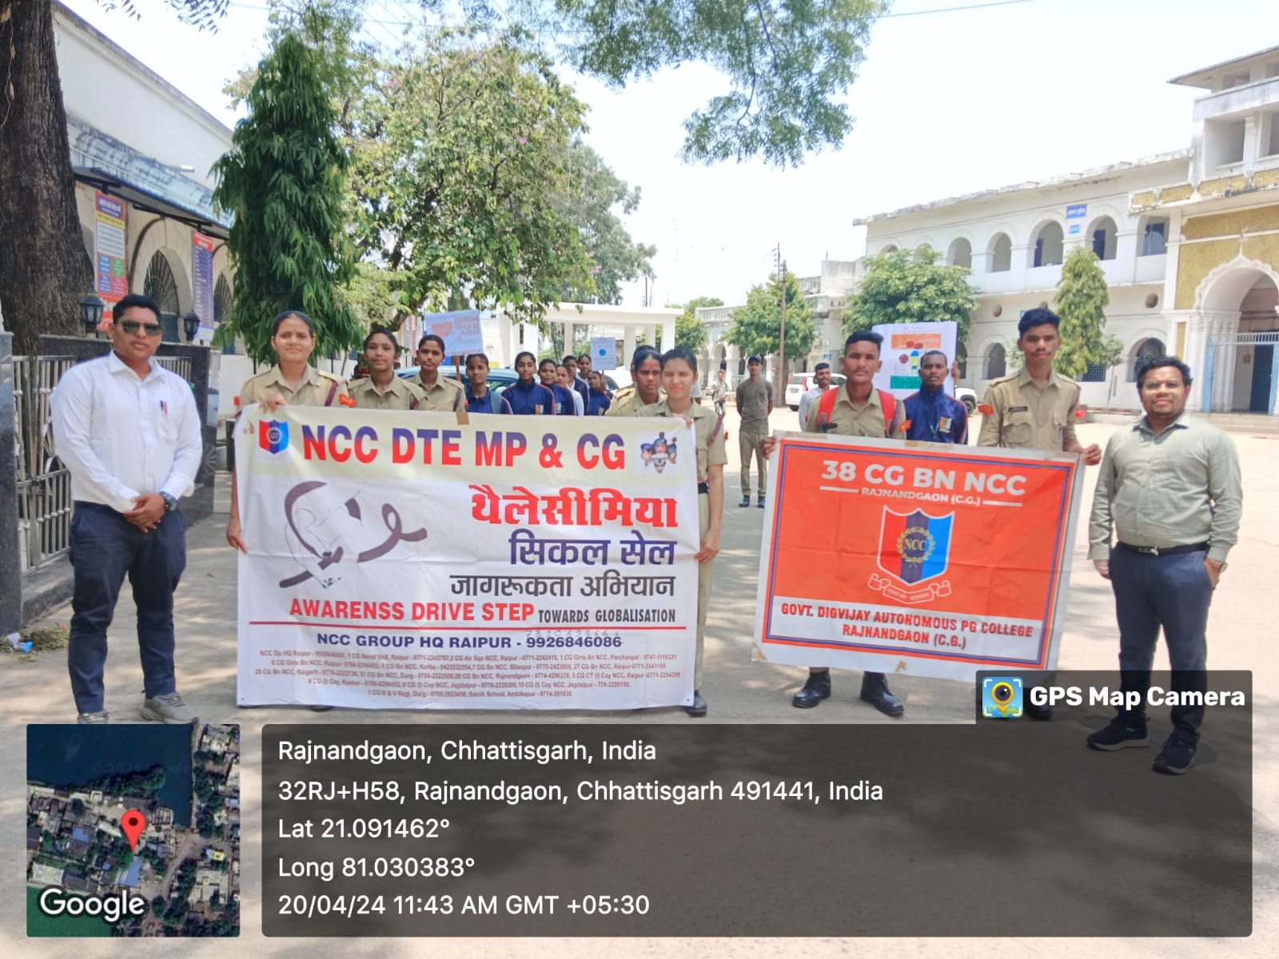

38 CHHATTISGARH BATTALION NCC
GOVT. DIGVIJAY AUTO. PG COLLEGE RAJNANDGAON (C.G.)

NCC April 2024
Ser No | Name of Institution | Name of Event | No of Cadets | No of Photos | No of videos | Remarks
1 | GOVT. DIGVIJAY AUTO. PG COLLEGE RAJNANDGAON | - Guest Lecture on sickle cell and thalassemia .  - Poster making competition .  - Awareness campaign railly | 48 | 08 | 02 | --

SICKLE CELL AND THALASSEMIA AWARENESS CAMPAIGN

World Earth day
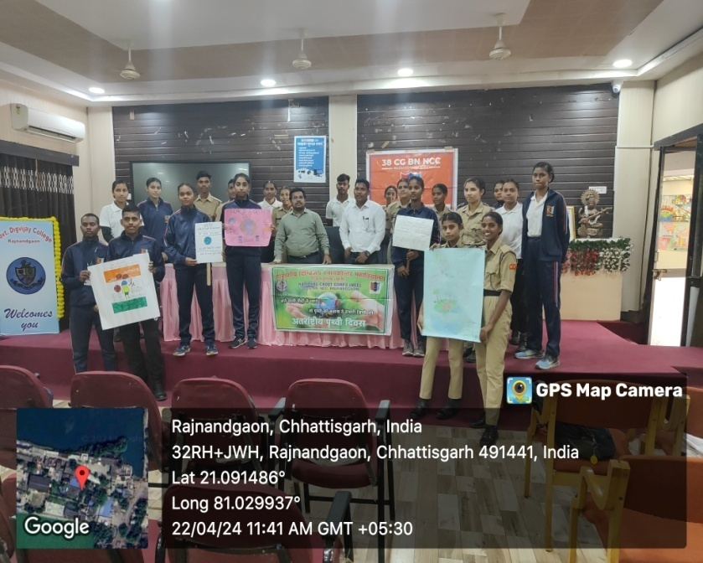

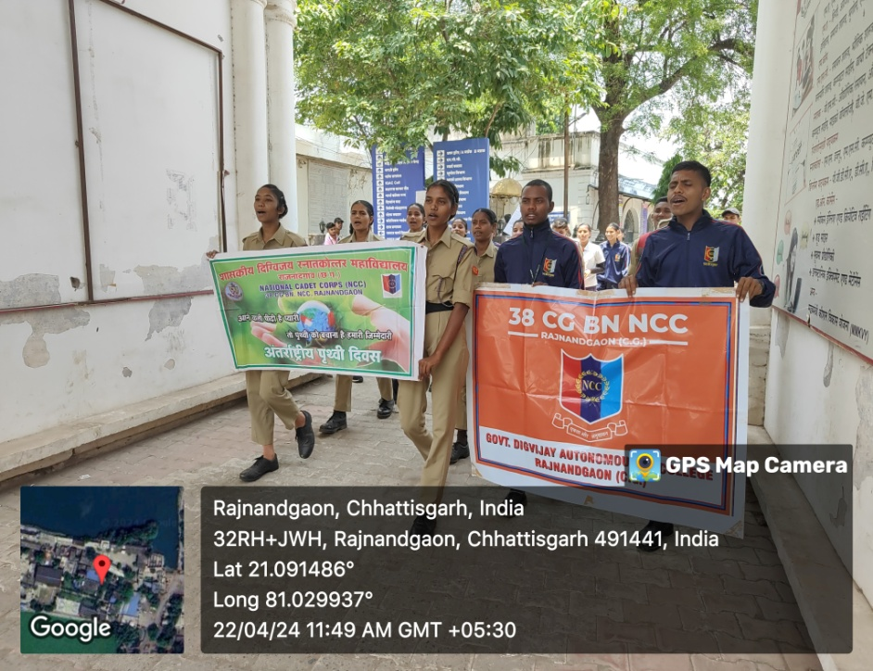

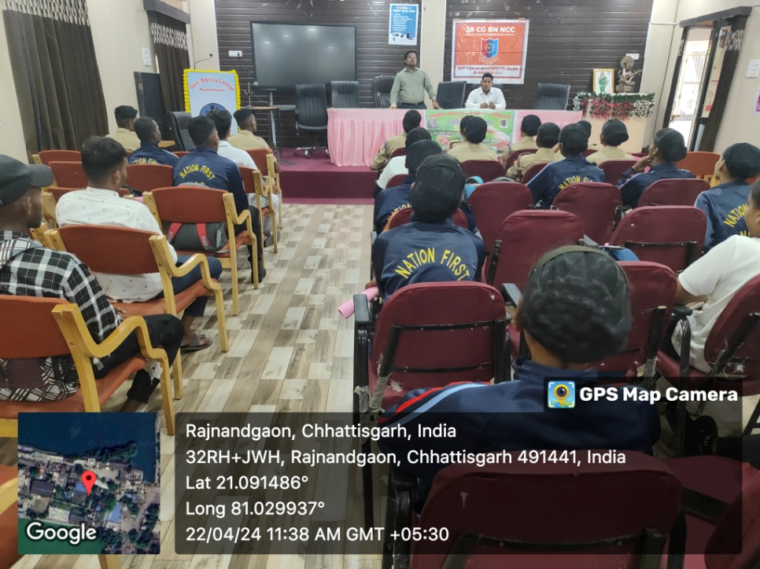

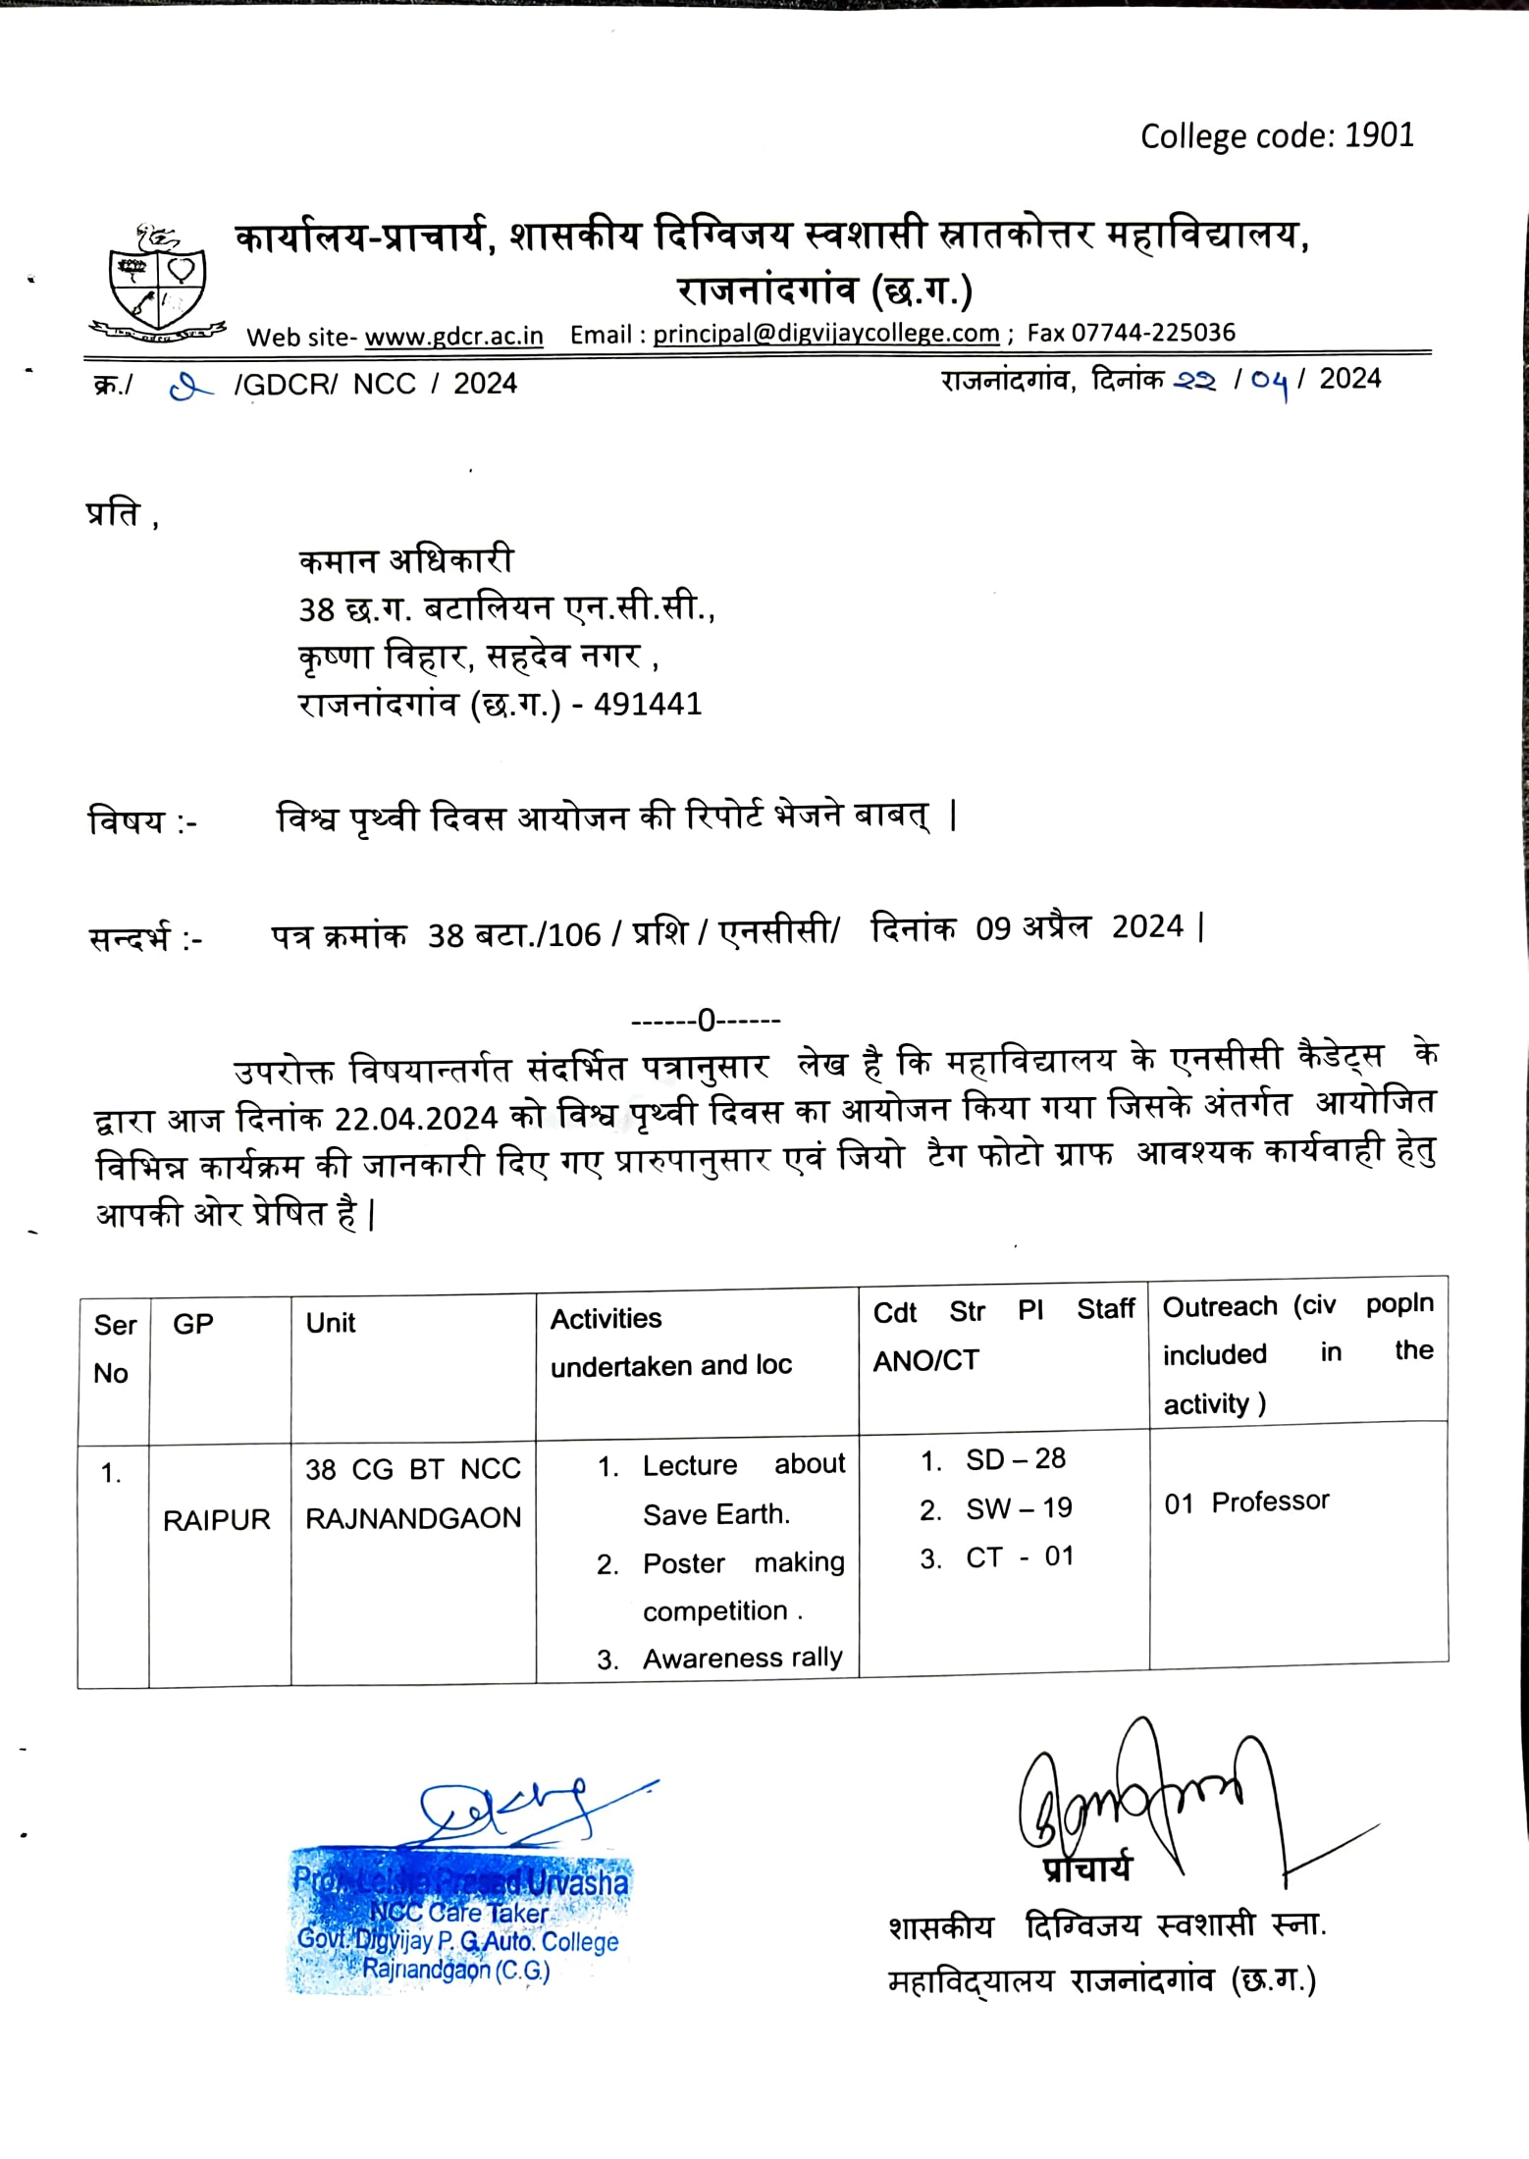

NCC DAY
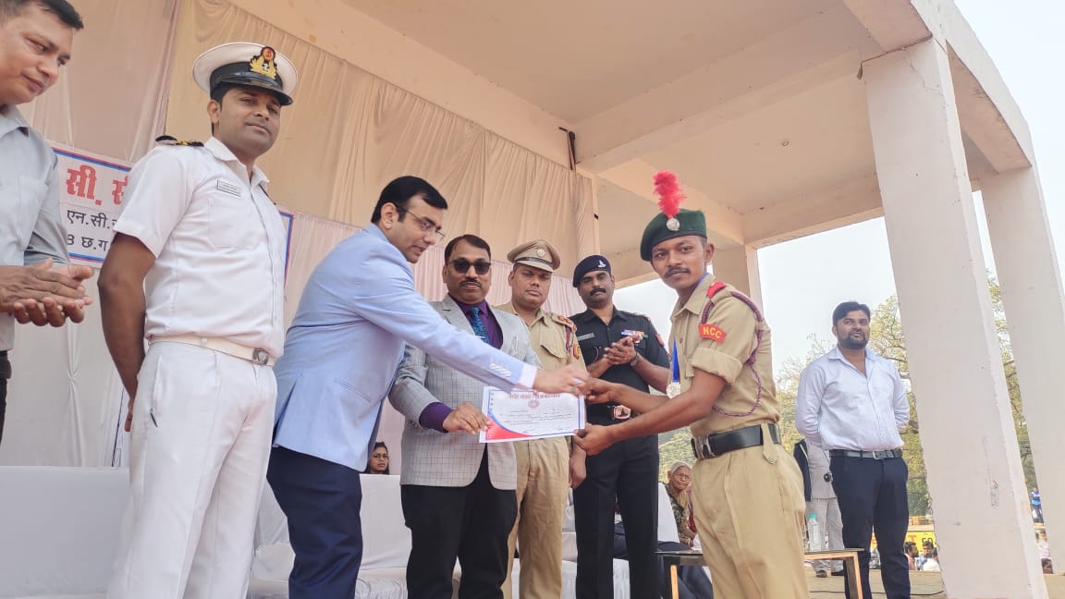

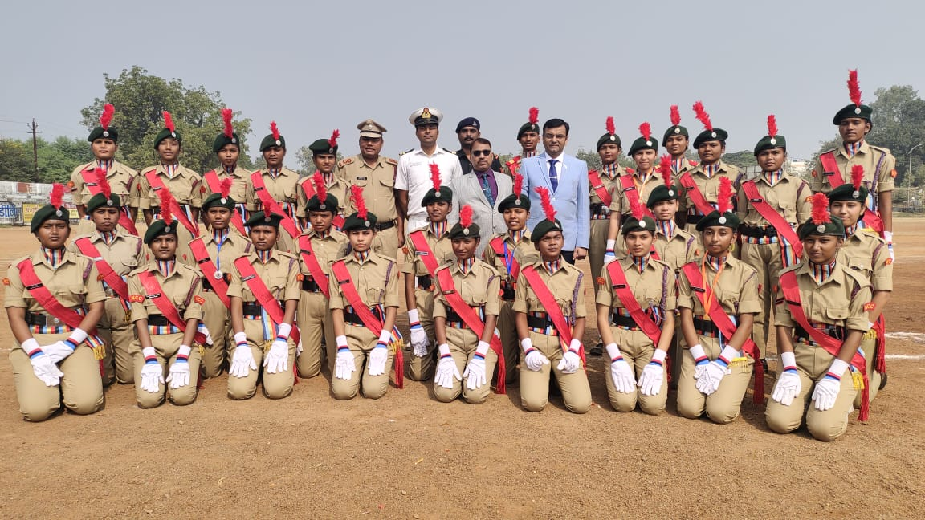

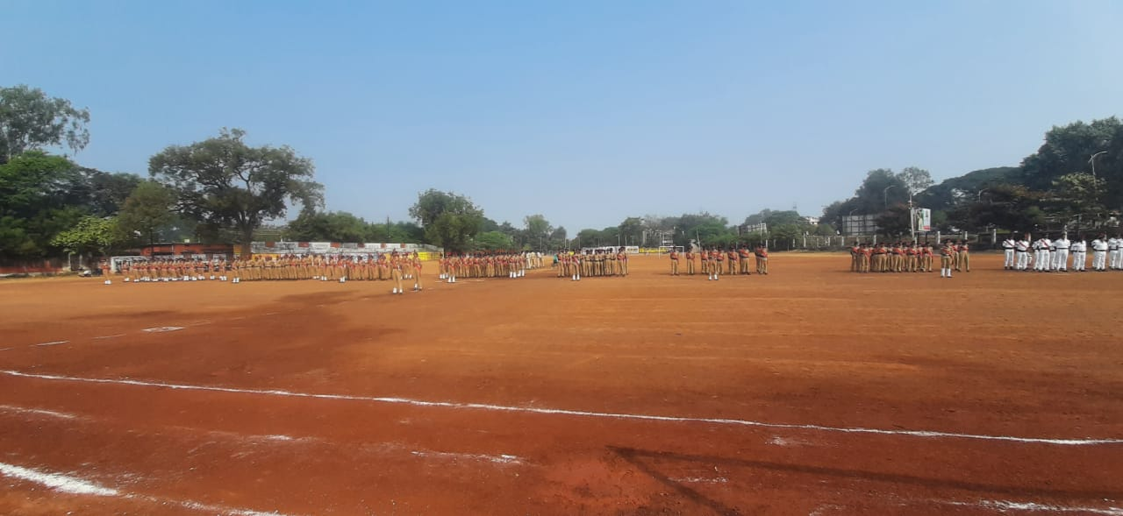

CLEANESS PROGRAM

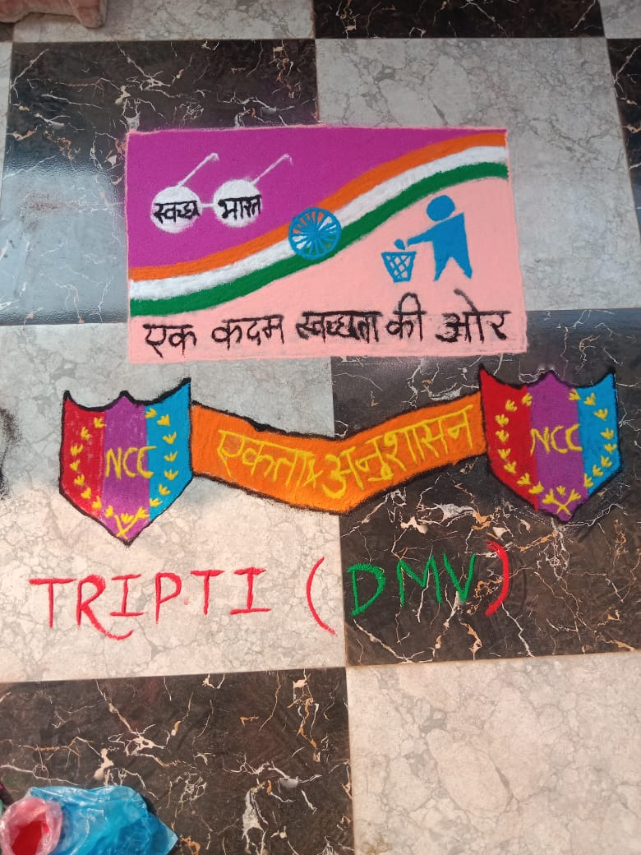
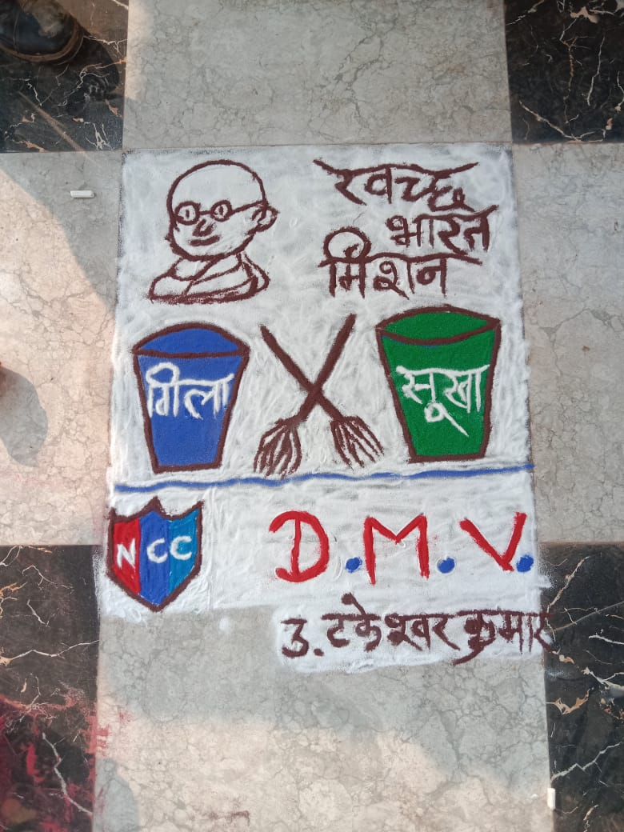
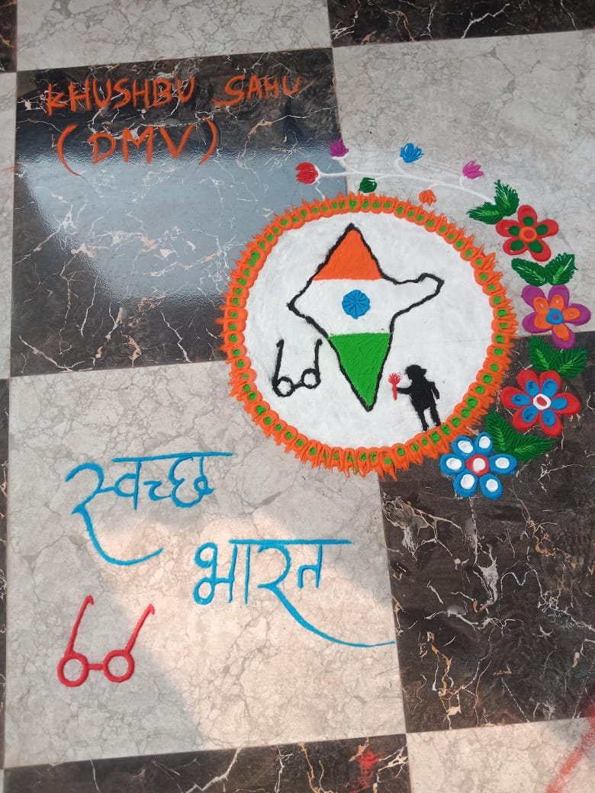

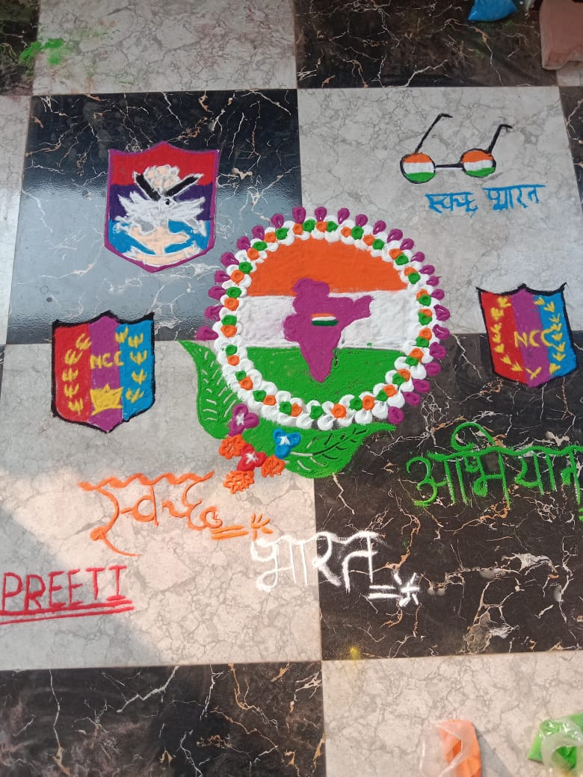

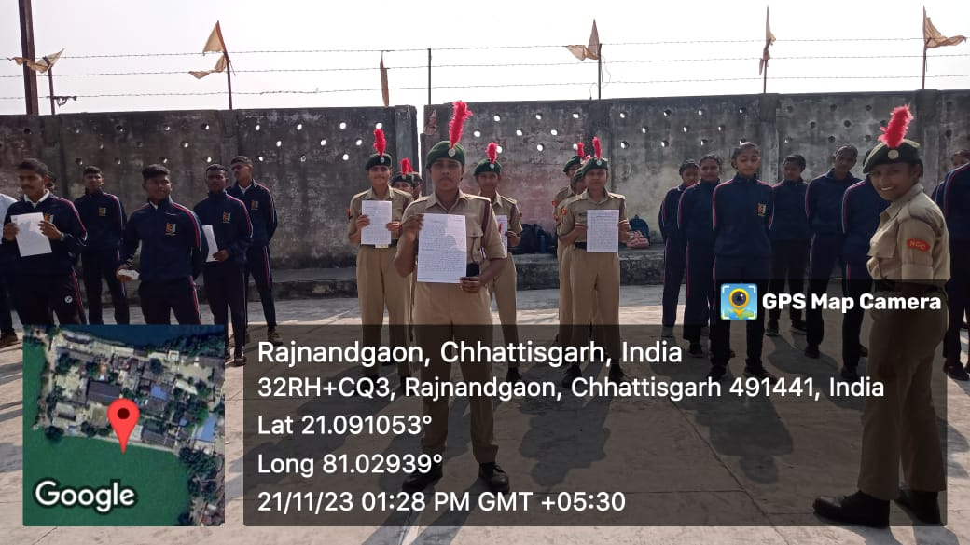

Sadbhawna diwas
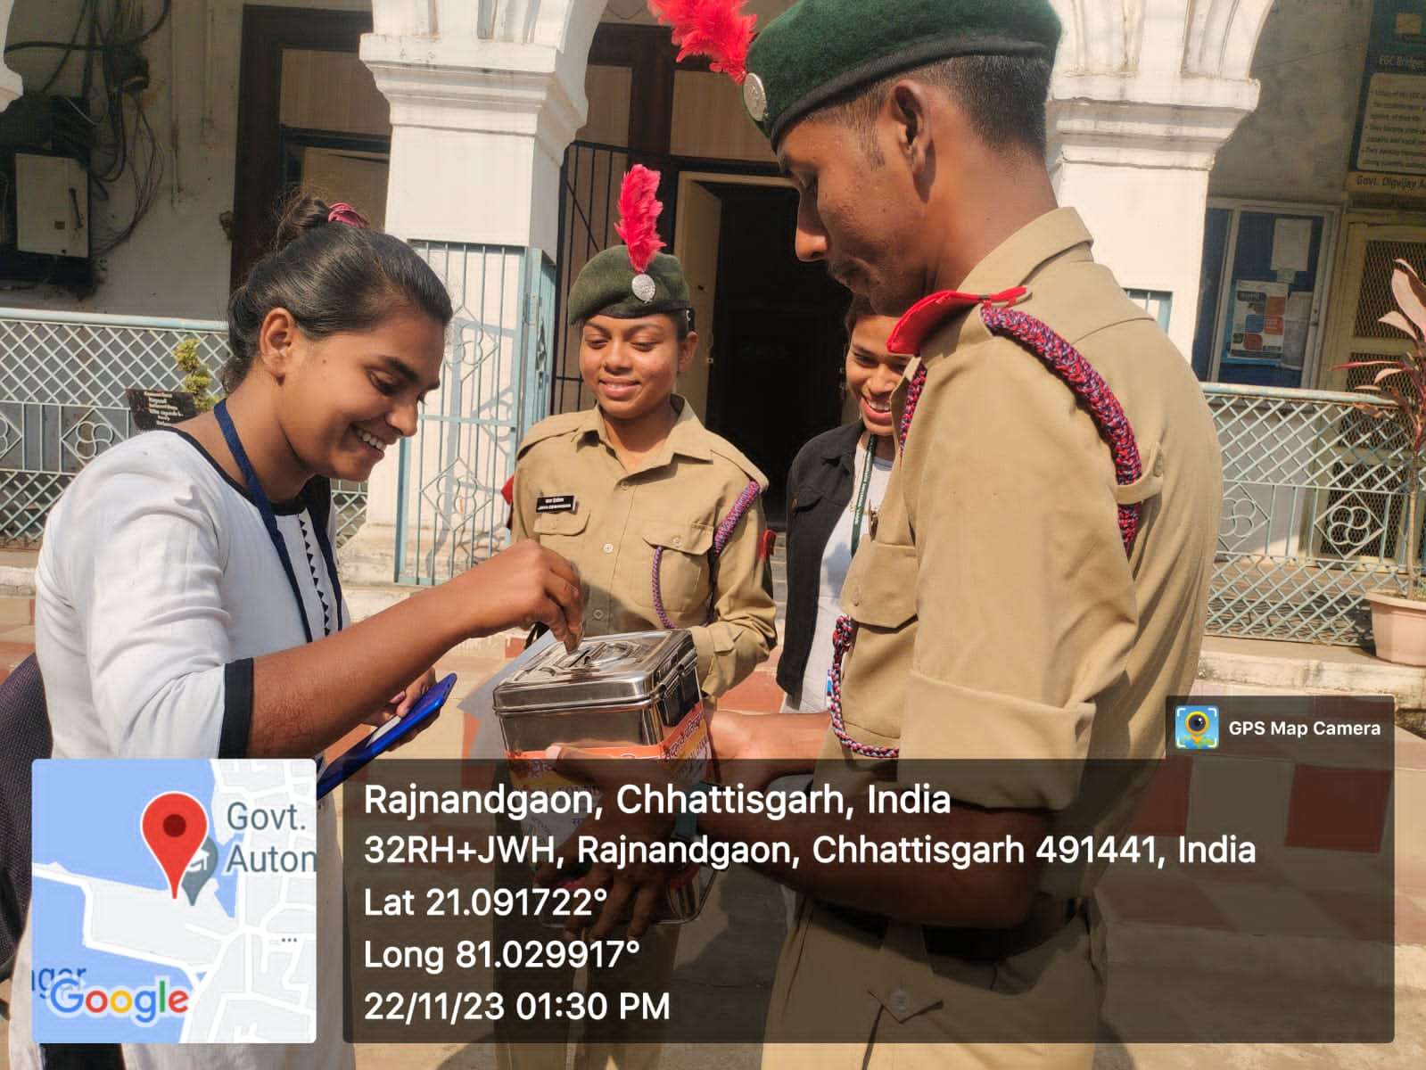

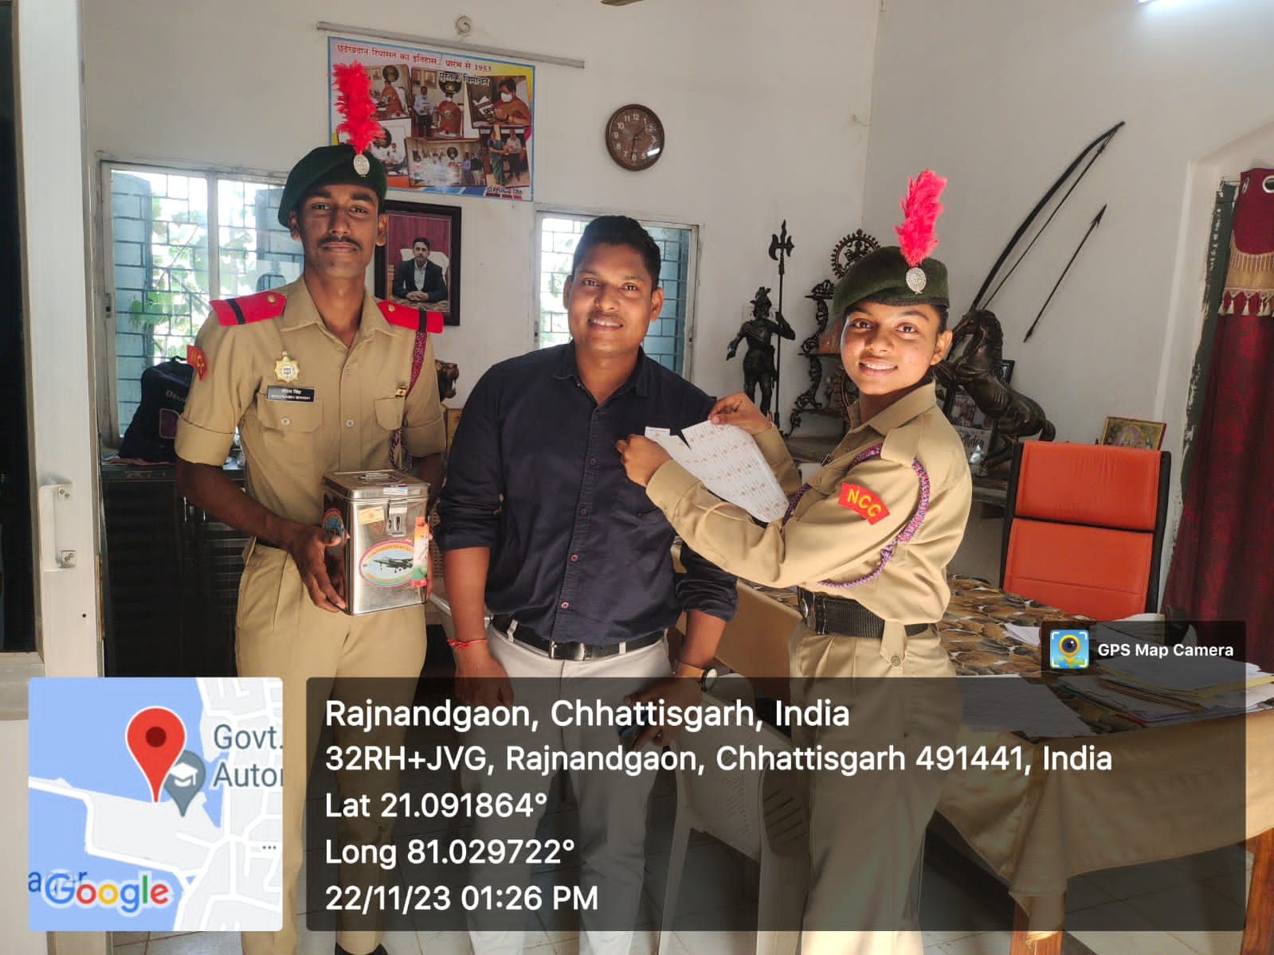

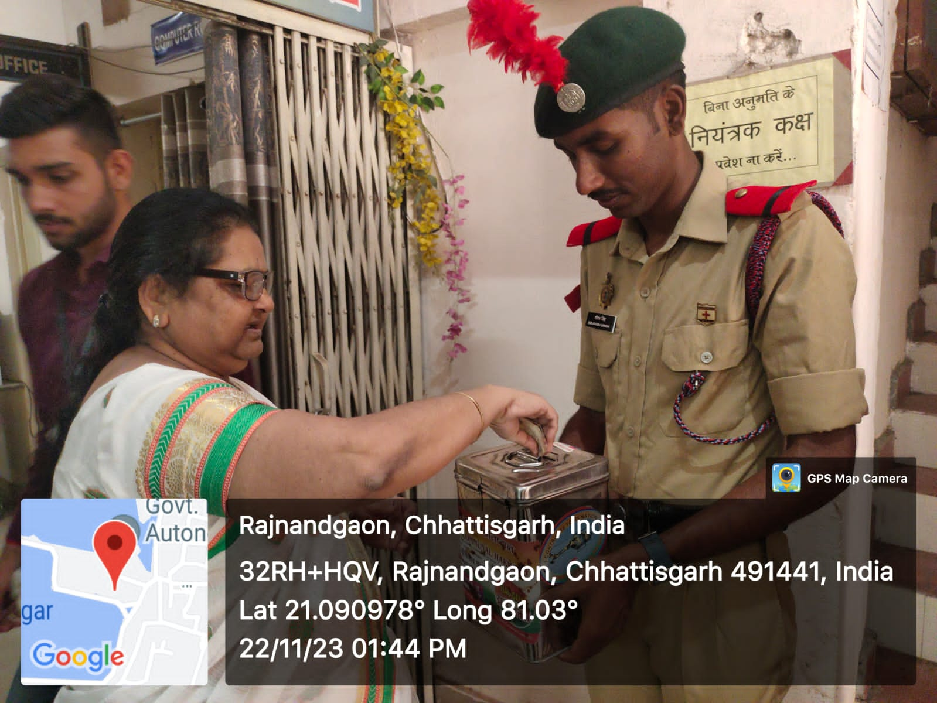

Polish smriti diwas
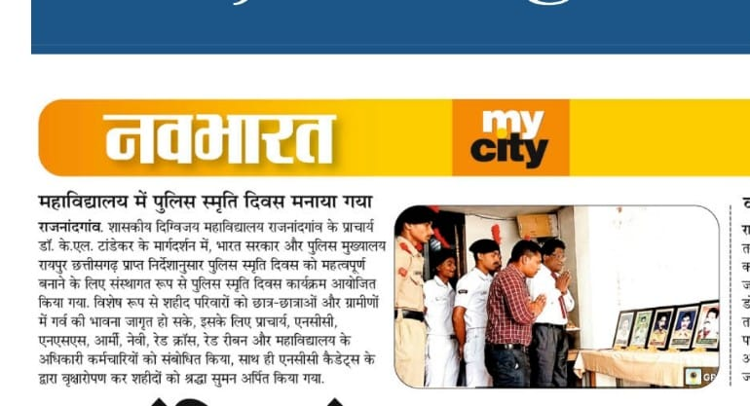

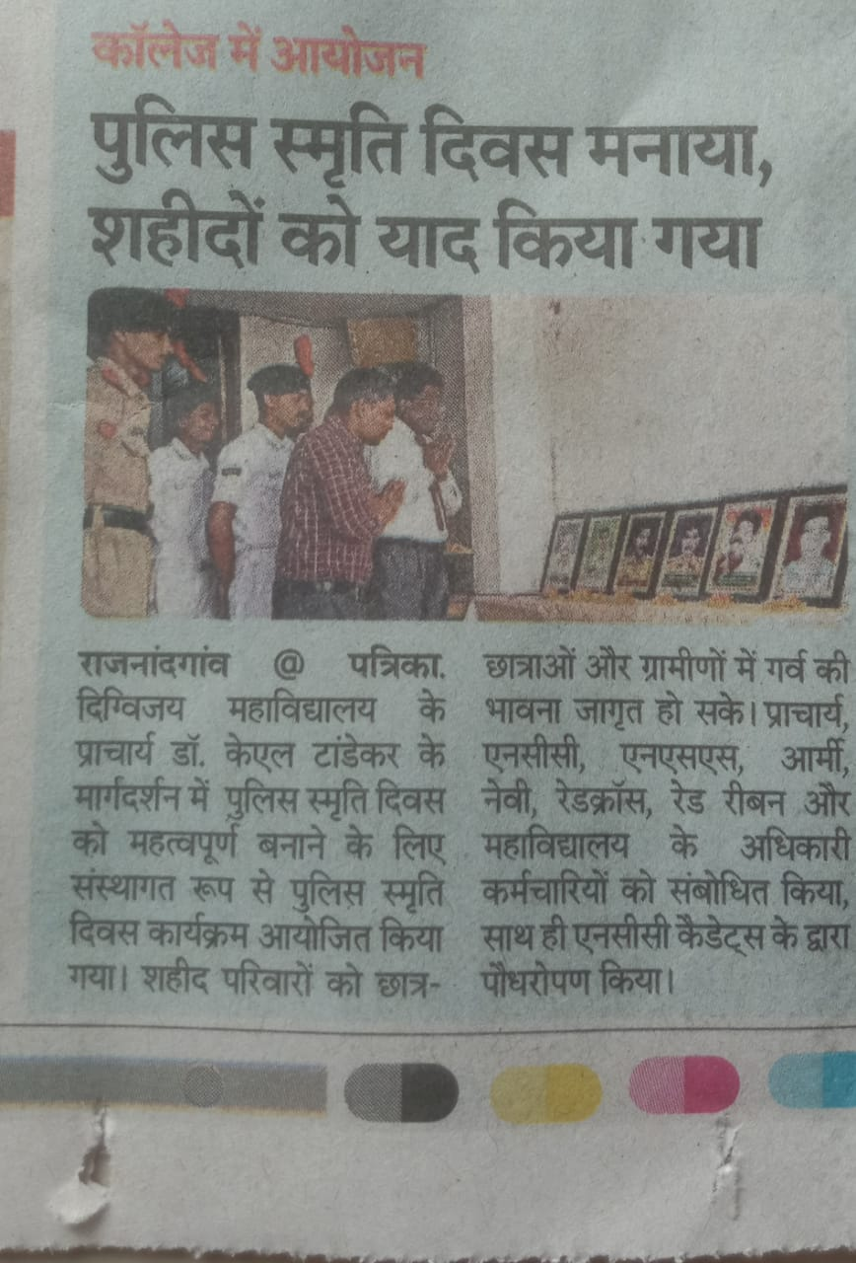

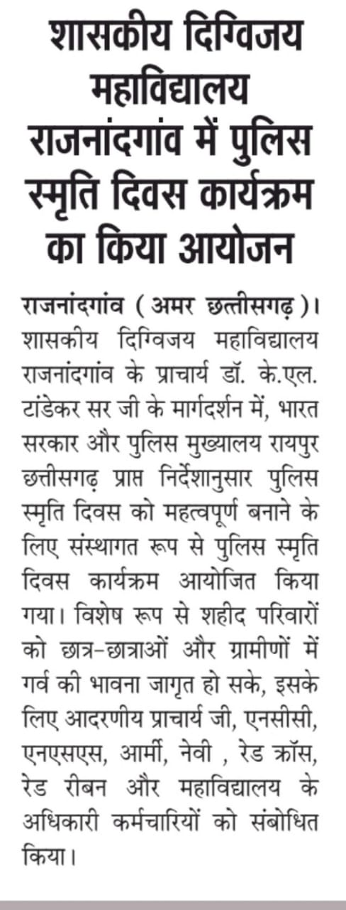

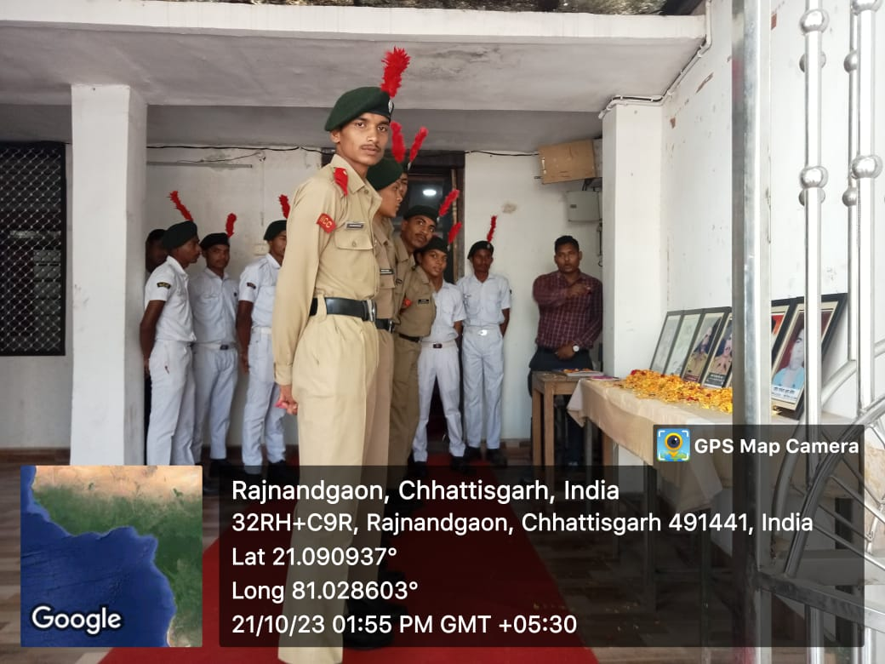

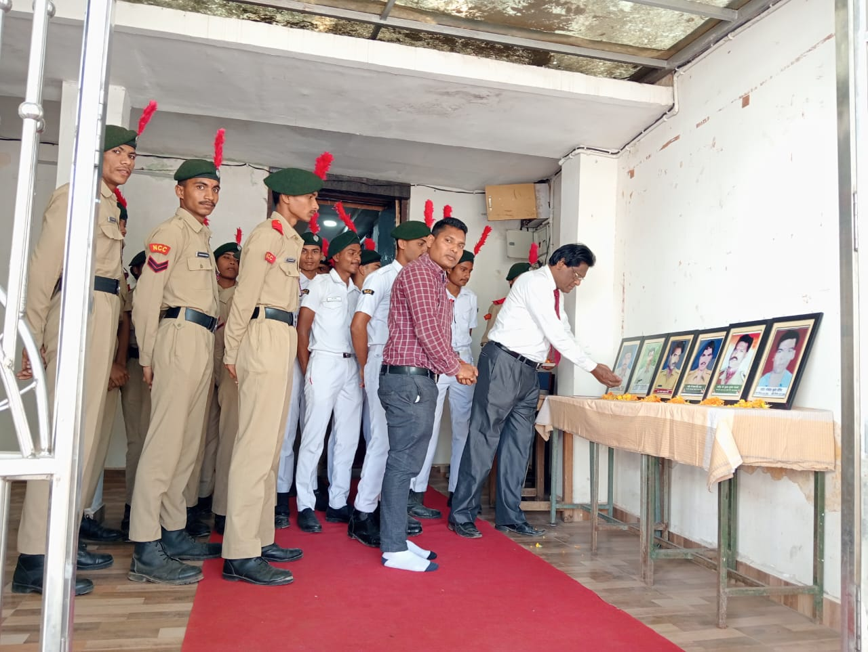

02 october ( swachhata hi seva )
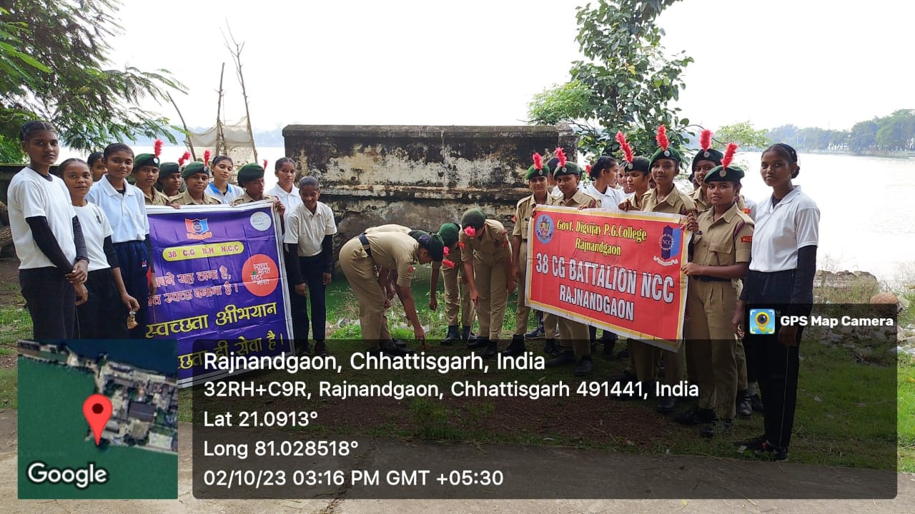

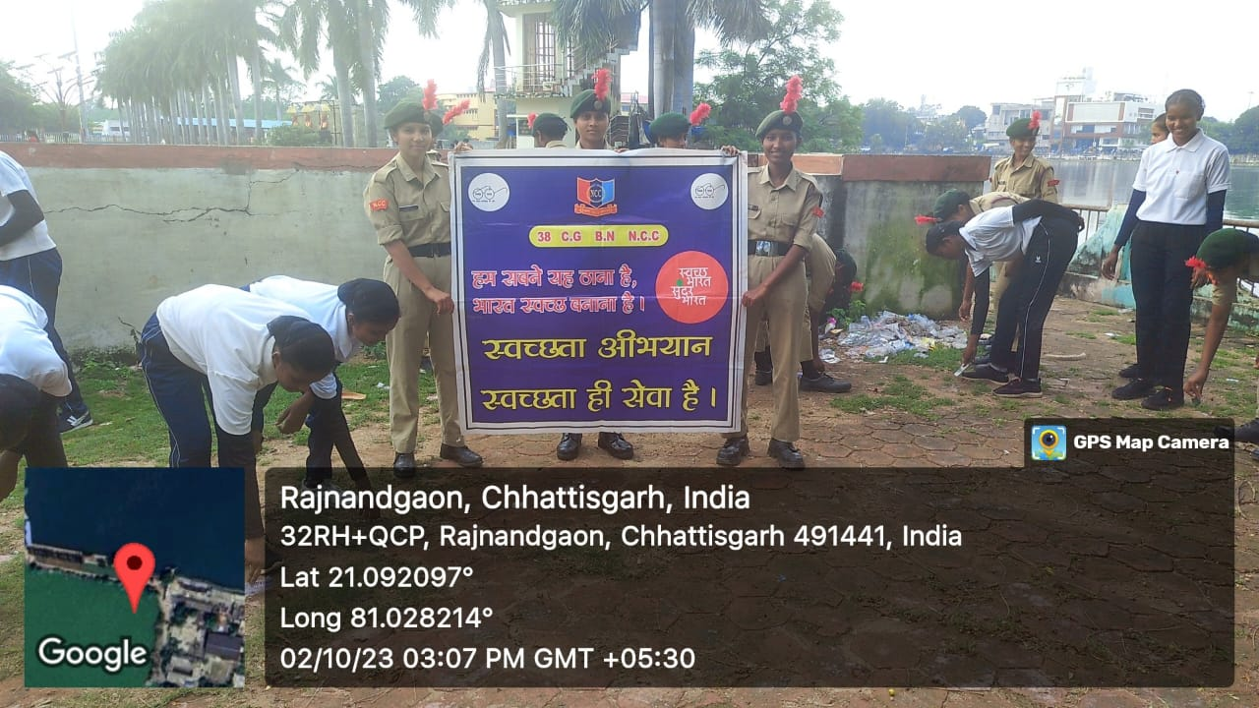

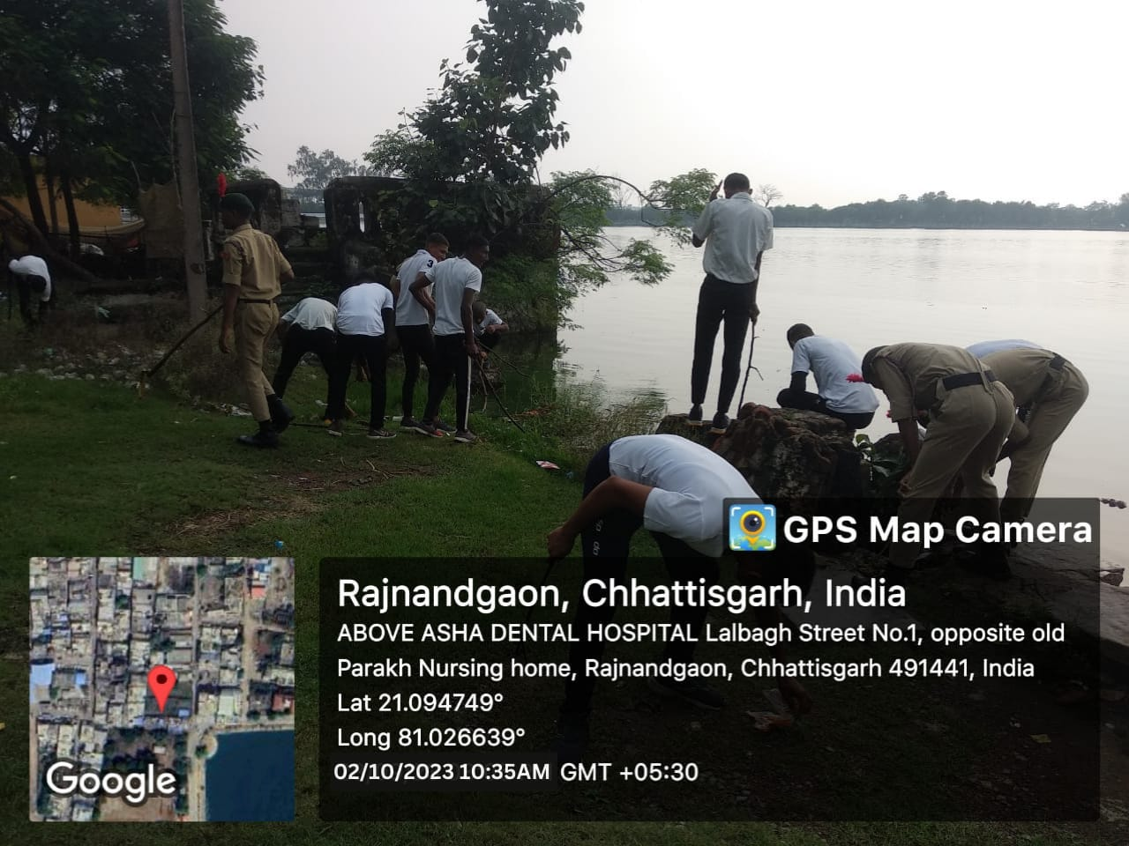

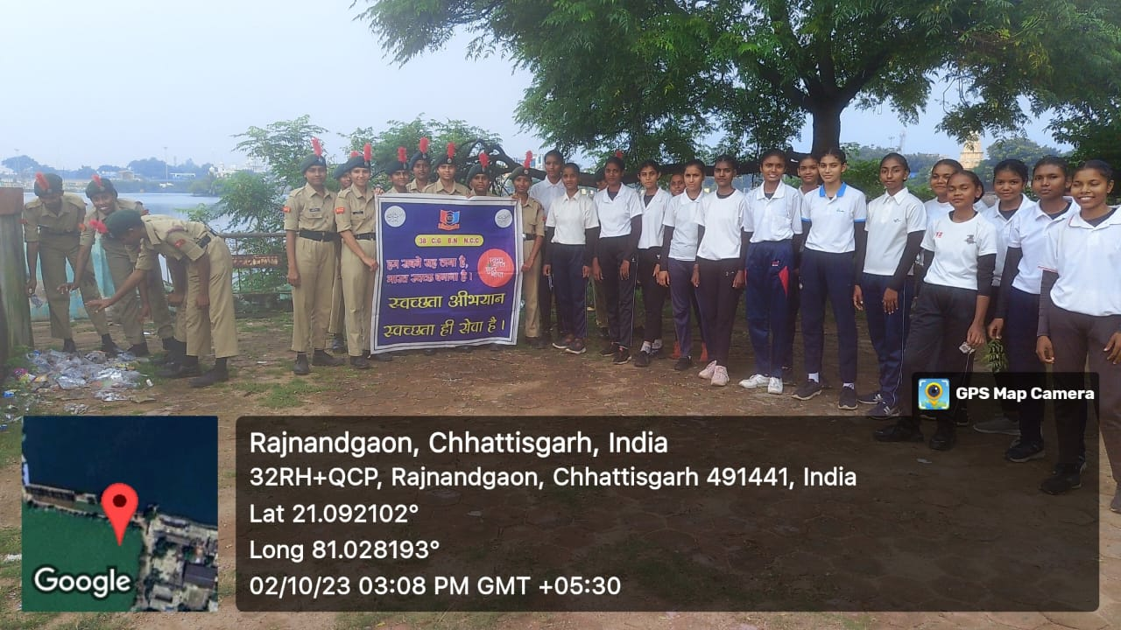

Punit Sagar Abhiyan( Cleanness Program )

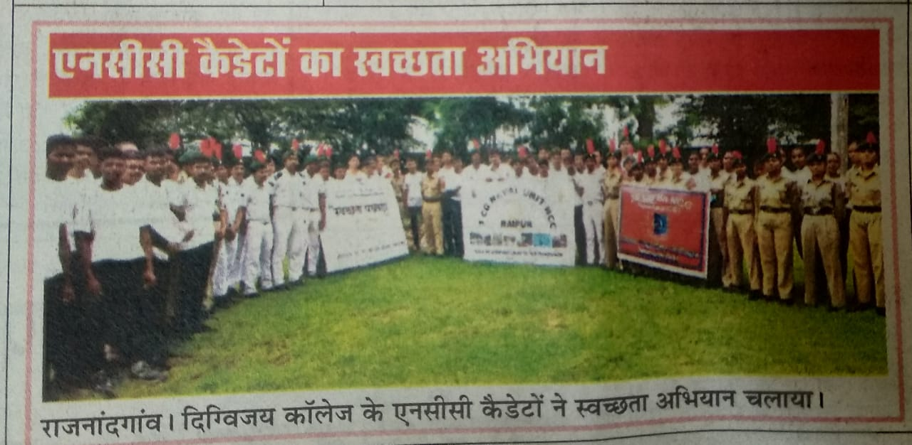
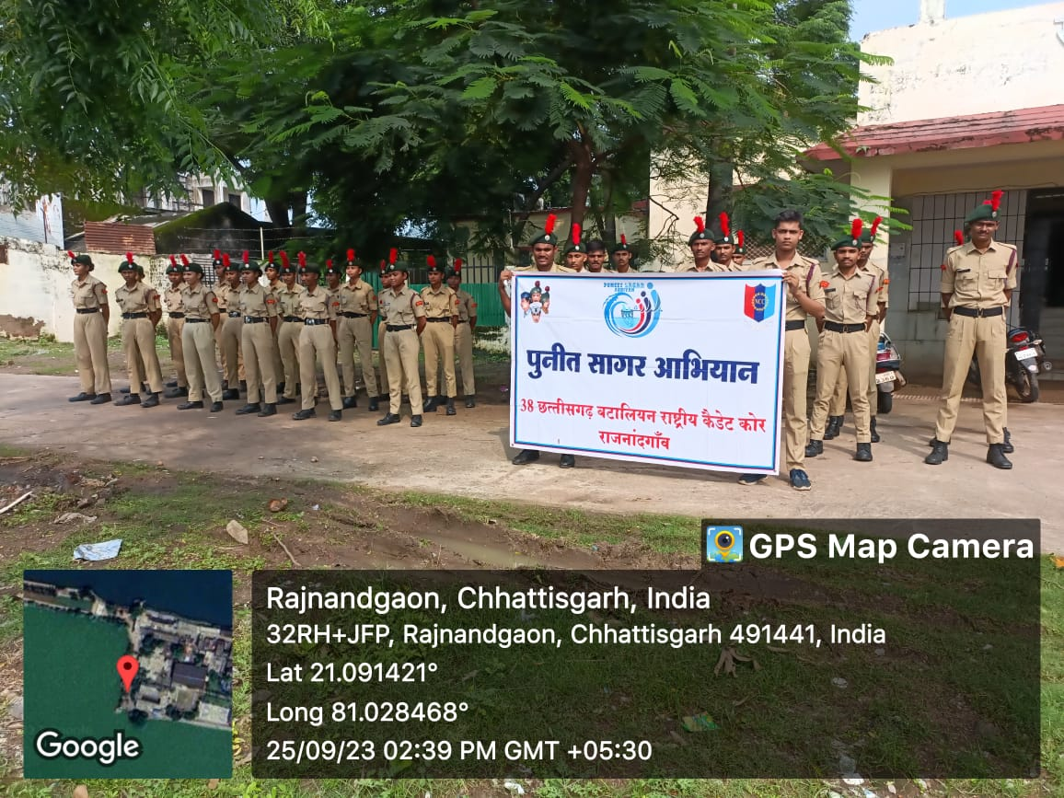

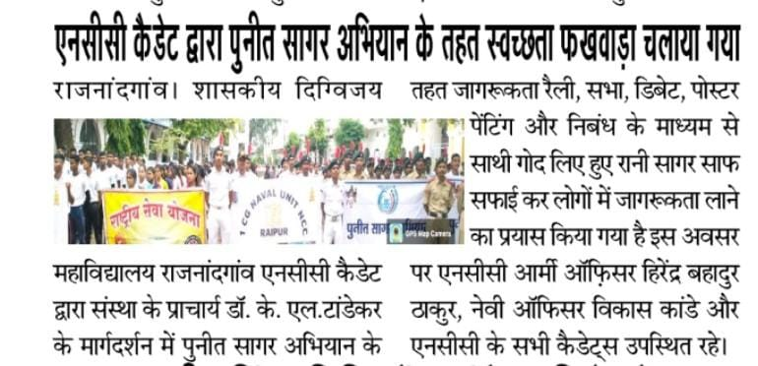

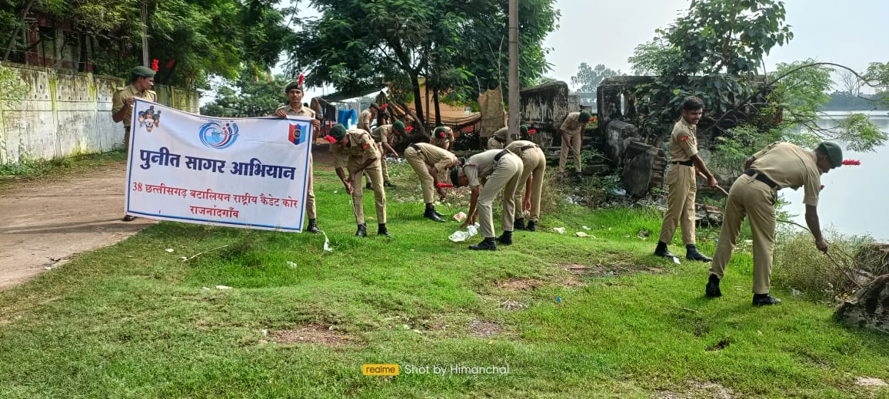

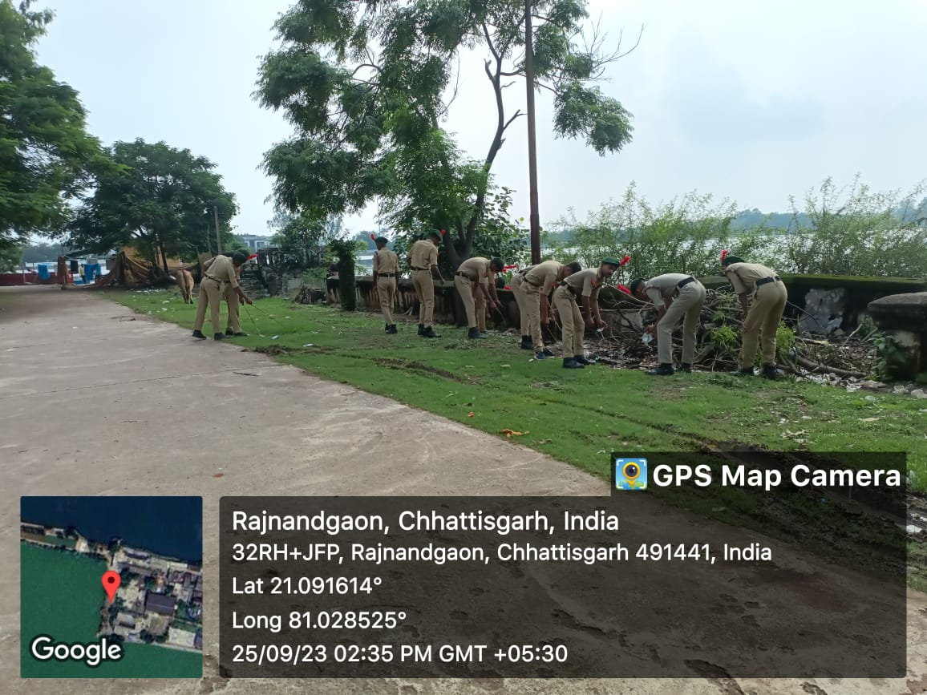

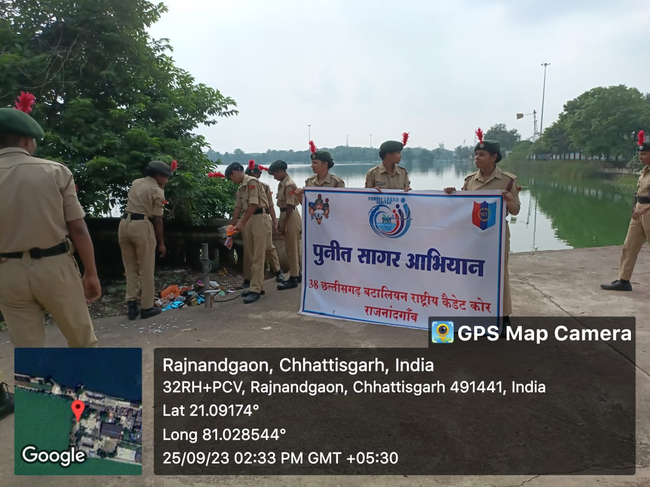

SWAKSHTA PAKHWADA (G20 THEME )
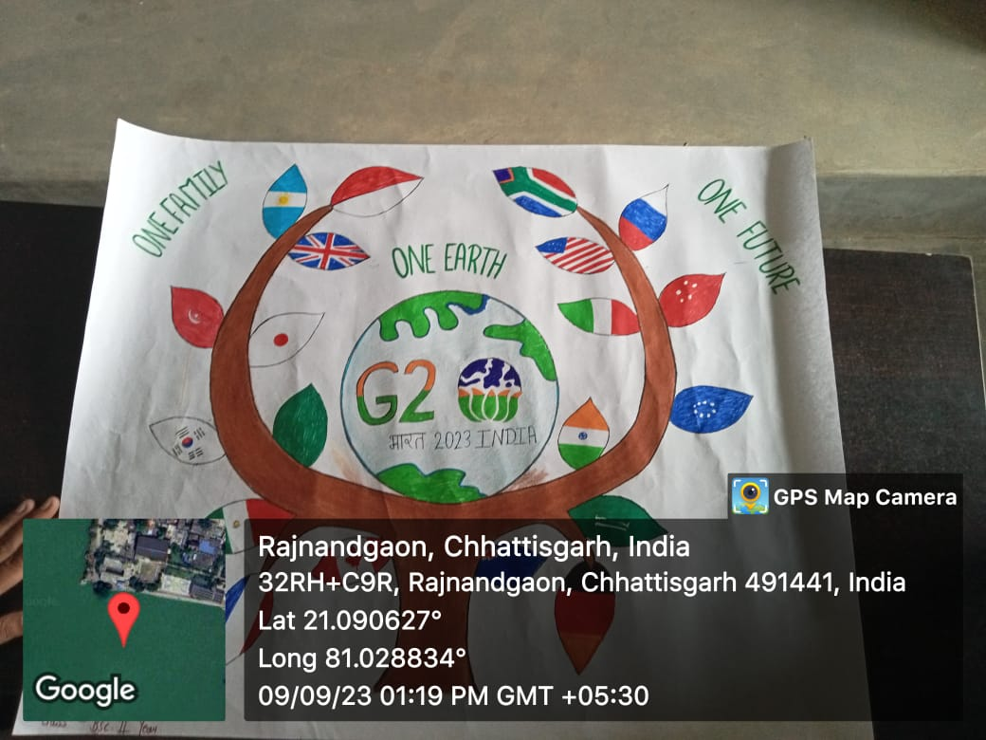

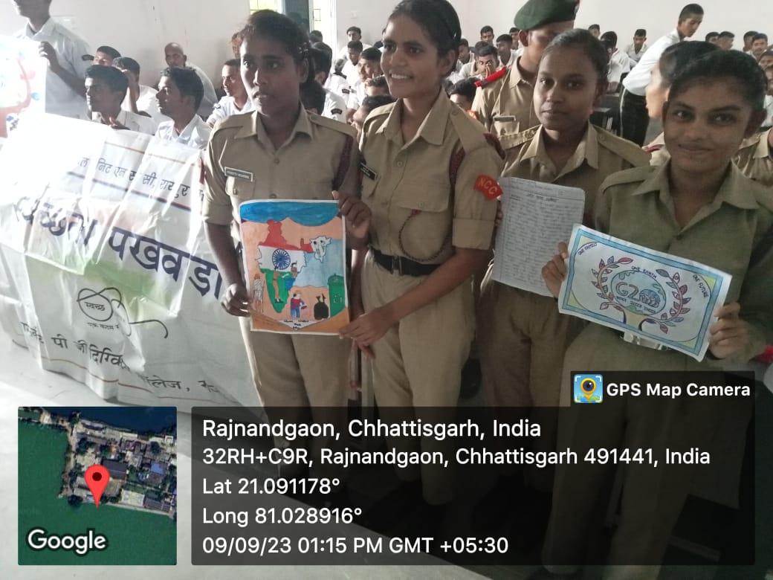

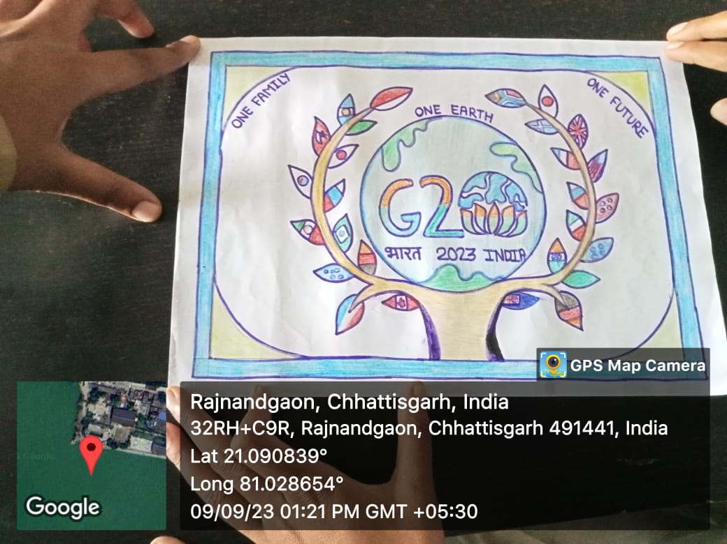

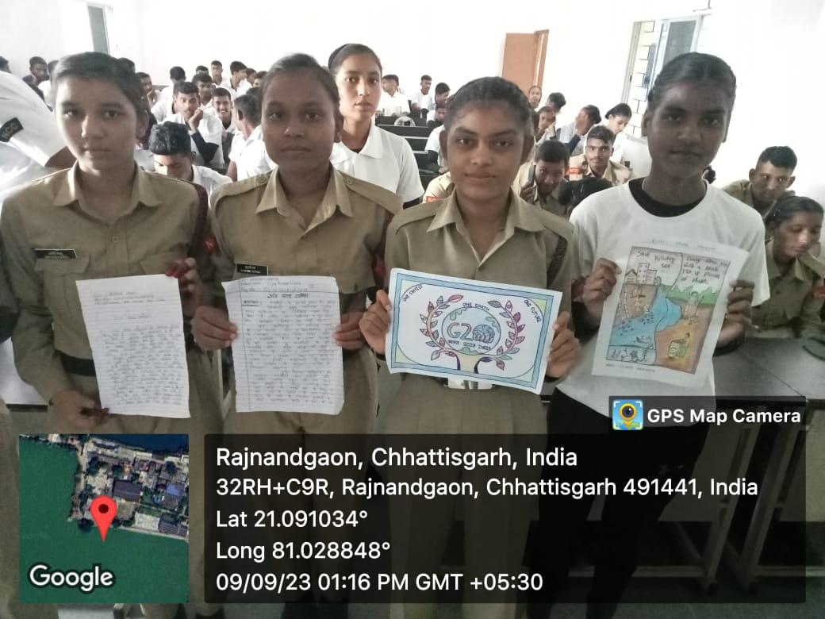

AGNIVEER SELECTION

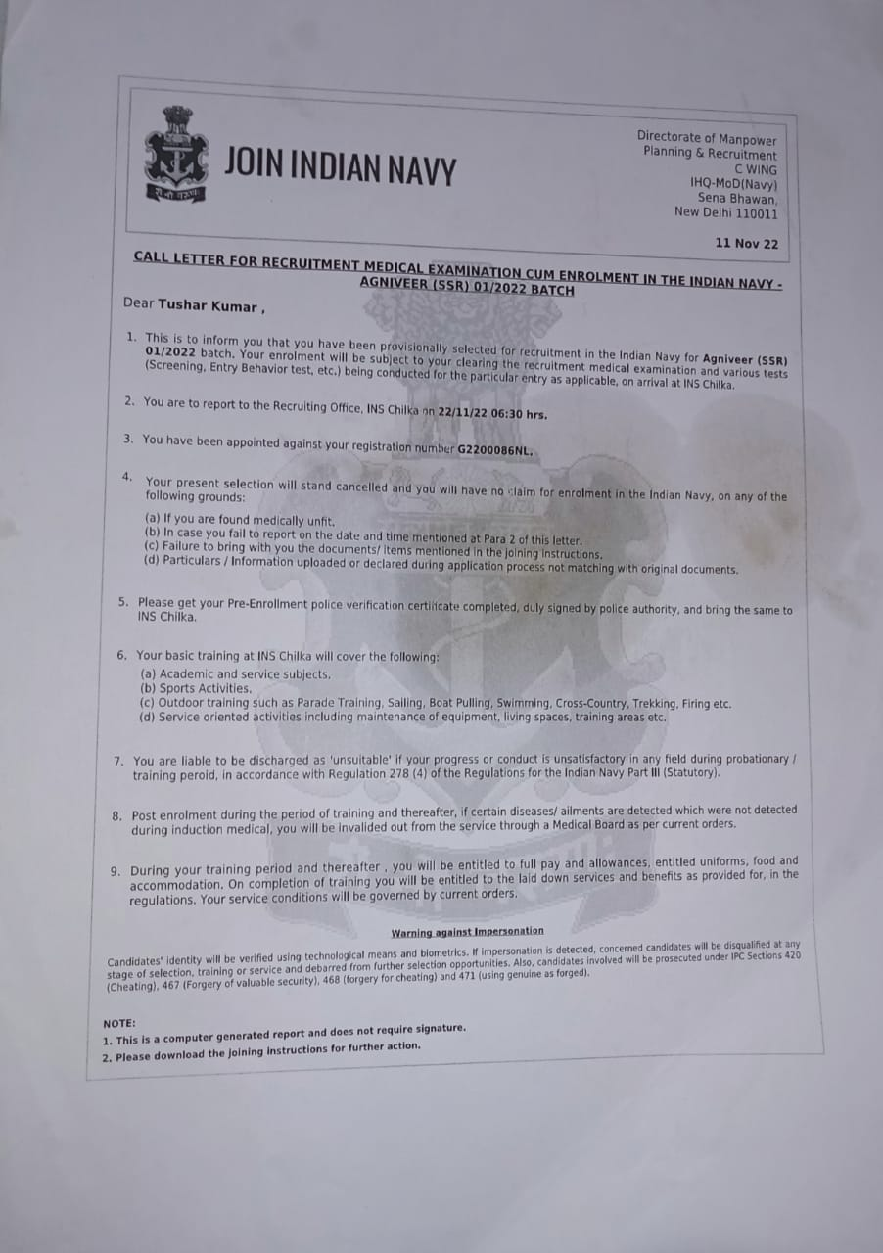

MOR MATI MOR DESH

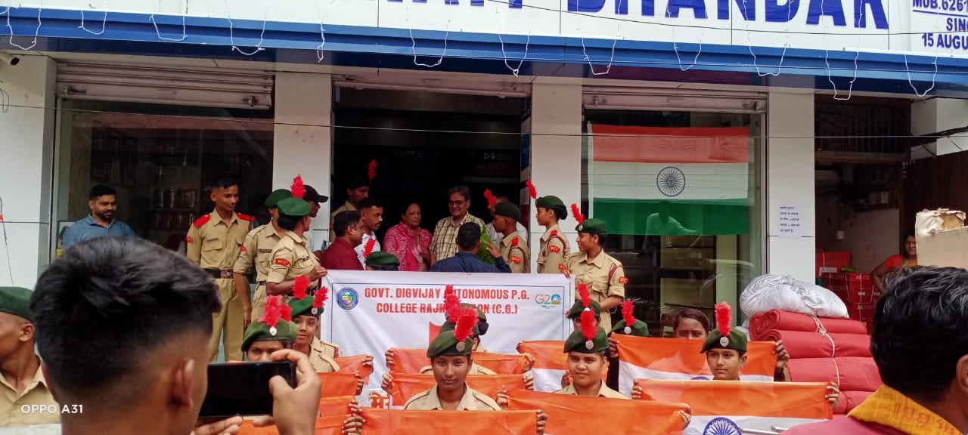

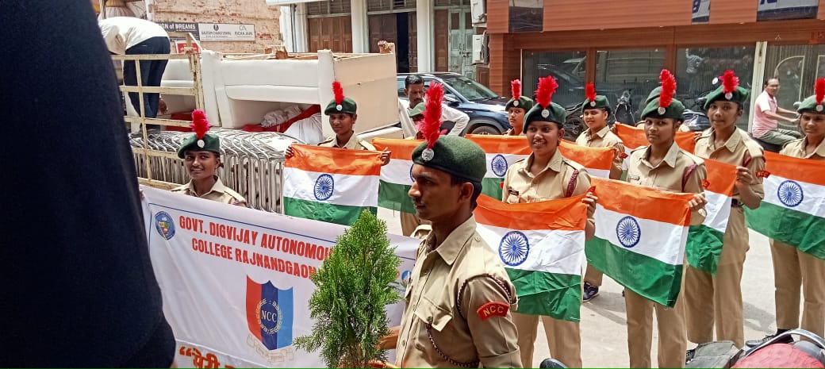

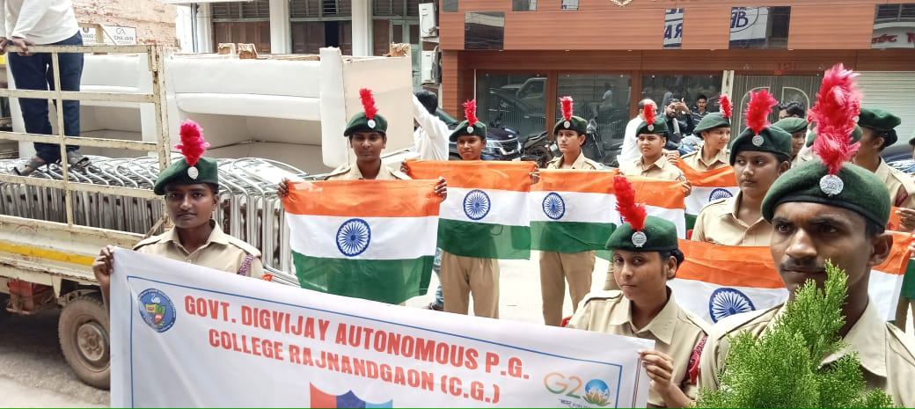

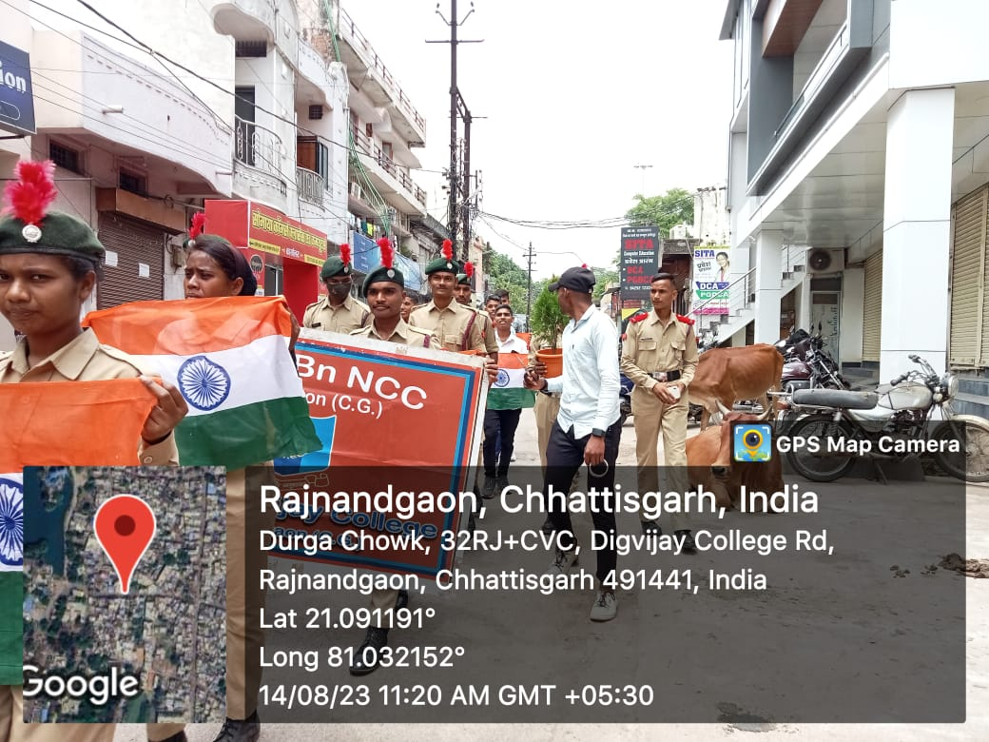

YOUTH DAY PROGRAM
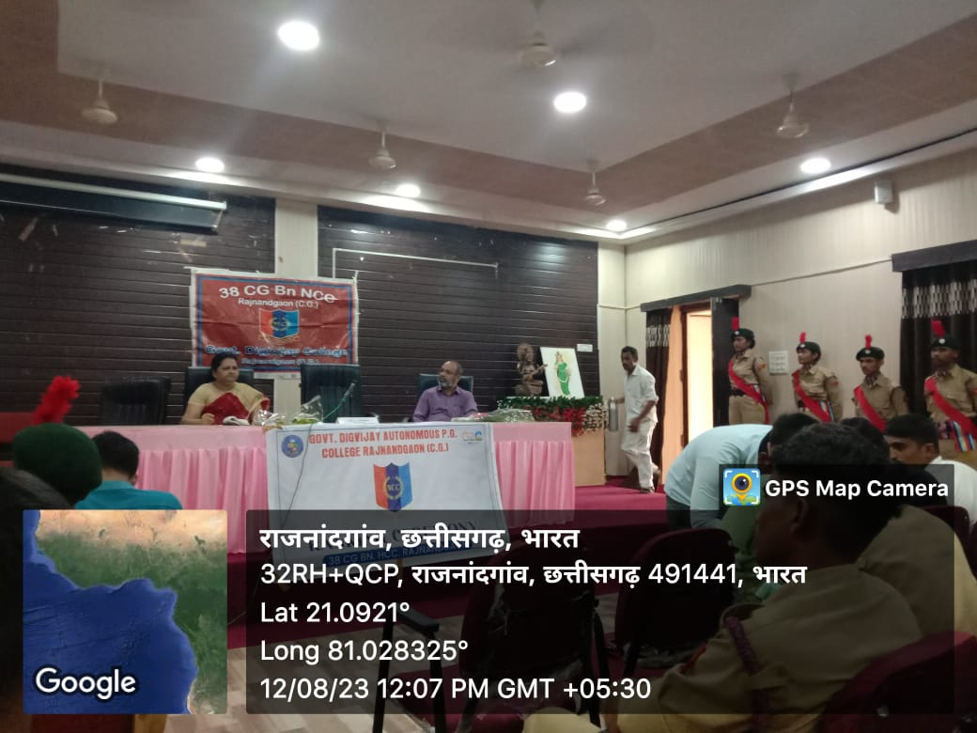
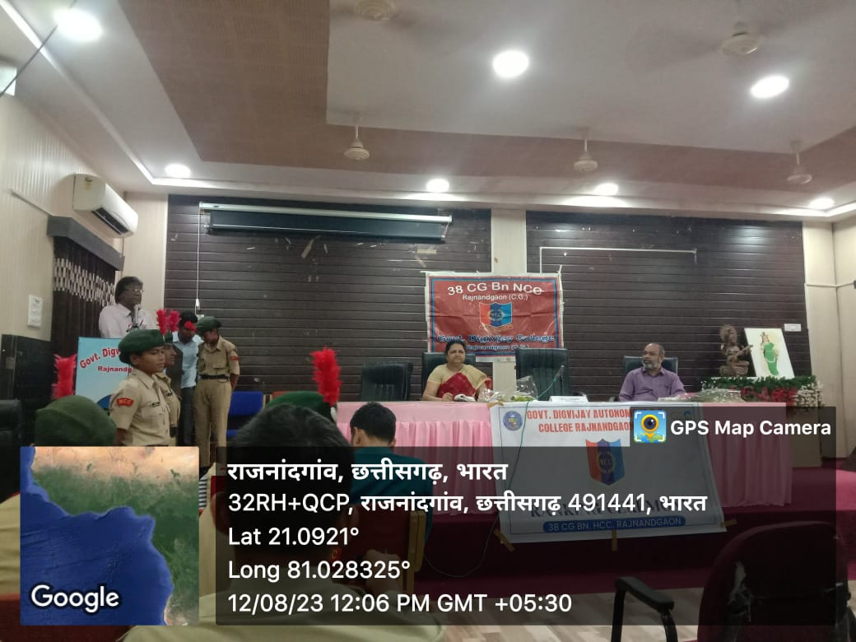

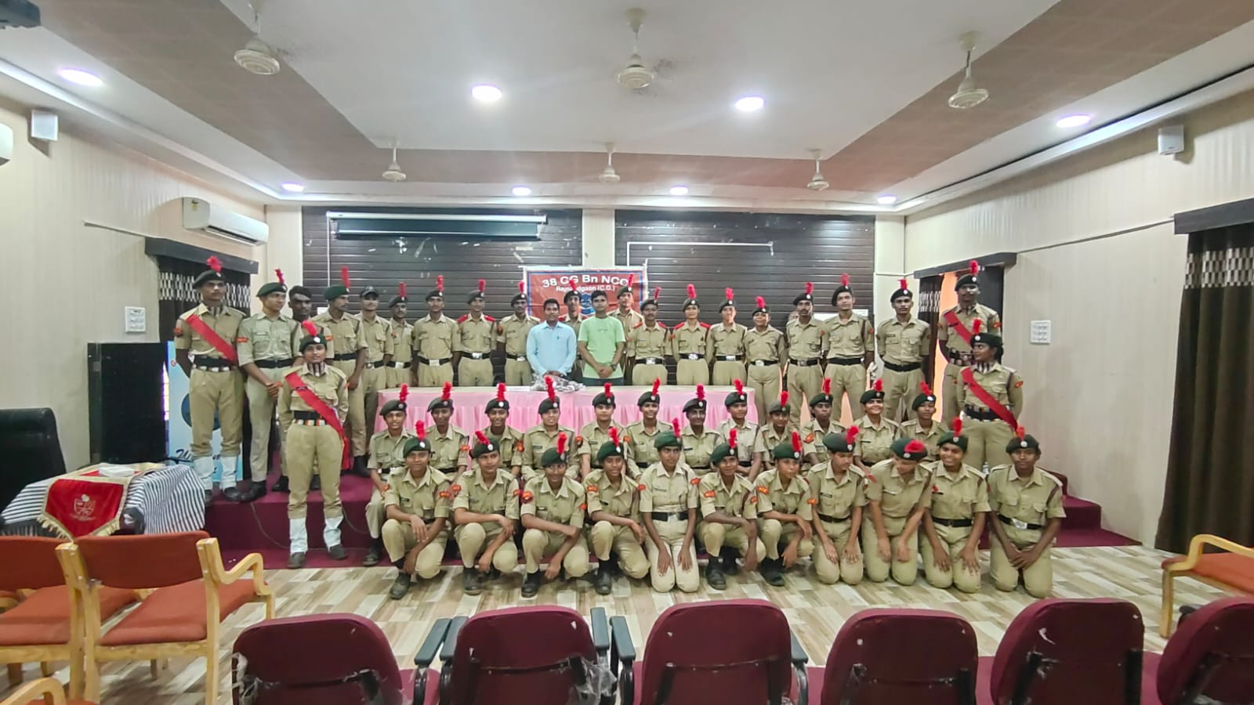


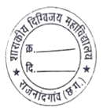

Principal
Govt. Digvijay Auto. PG College,
Rajnandgaon

